Randall Dunn Attack:
DAVE CAMPBELL: (to Randy Dunn) You weren’t even watching when he came out pushing on me. (02:28)
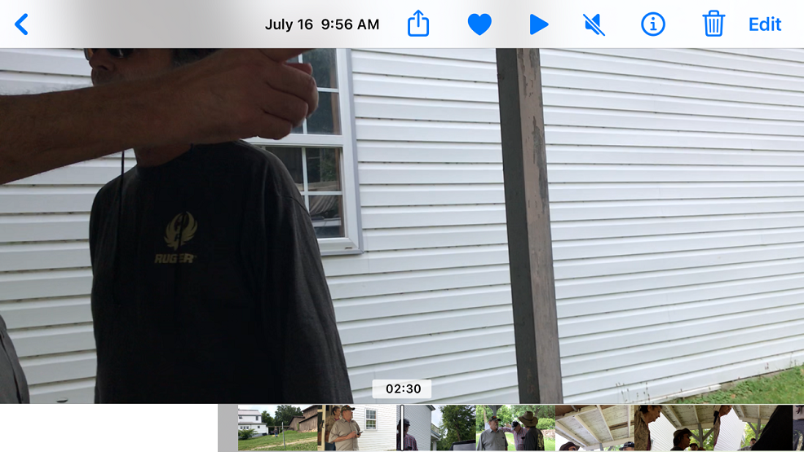
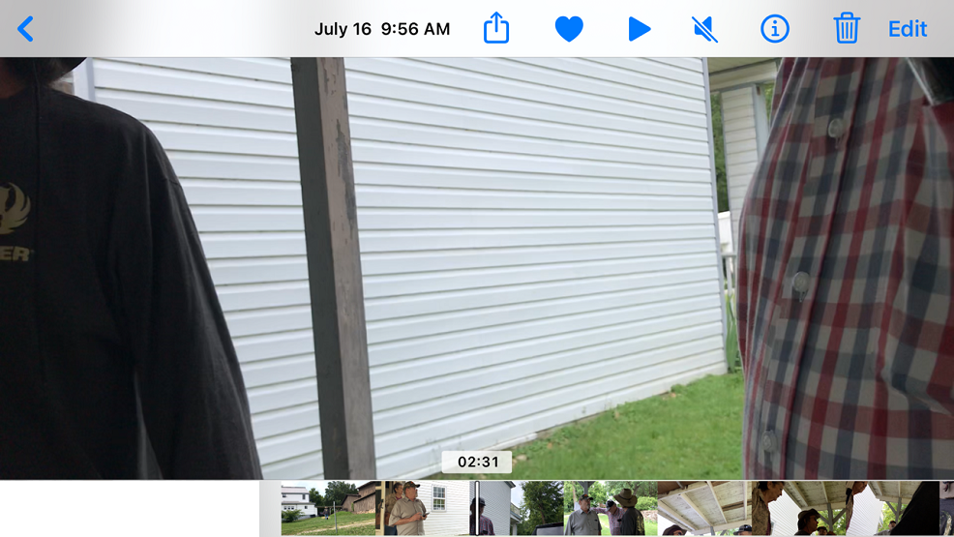
RANDY DUNN: (to Dave Campbell) I was, too. I was standing right here. (02:32)
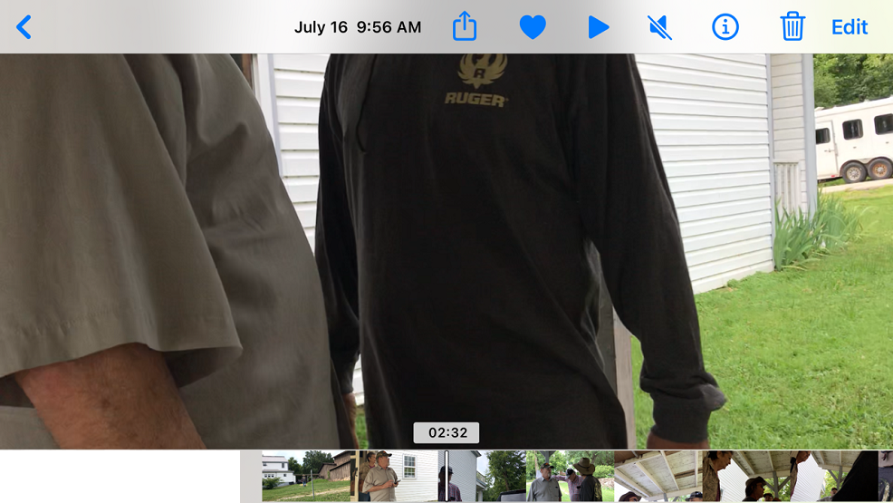
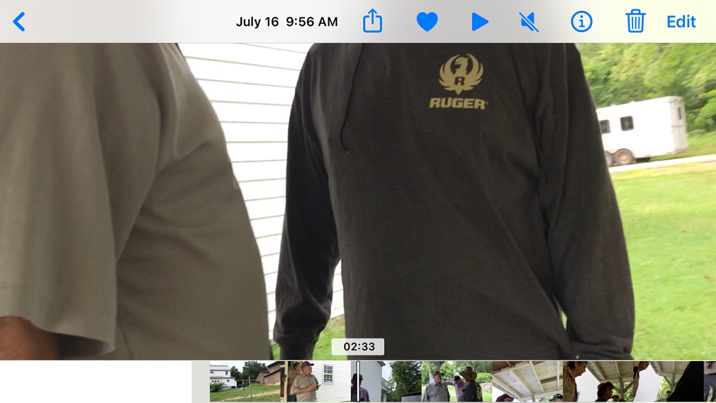

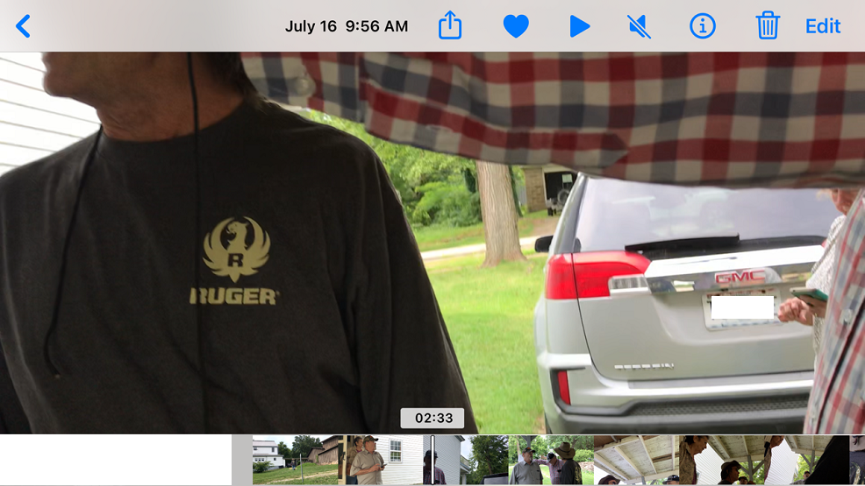
DAWN CAMPBELL (to Gary Dunn): You stay away from me, Sir. (02:34)
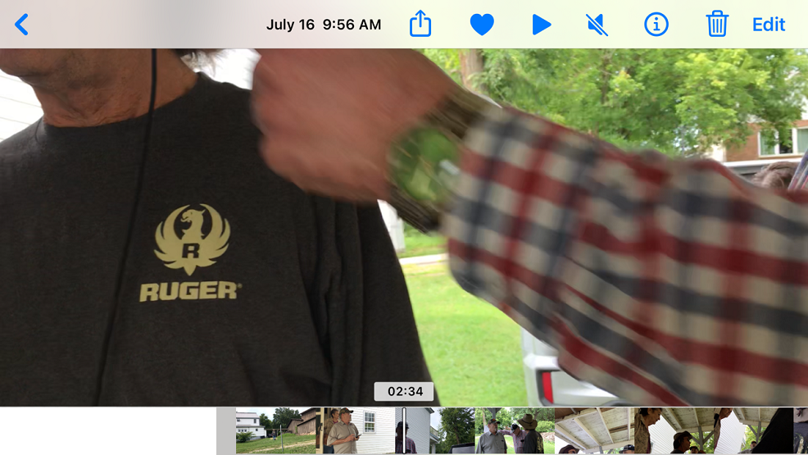
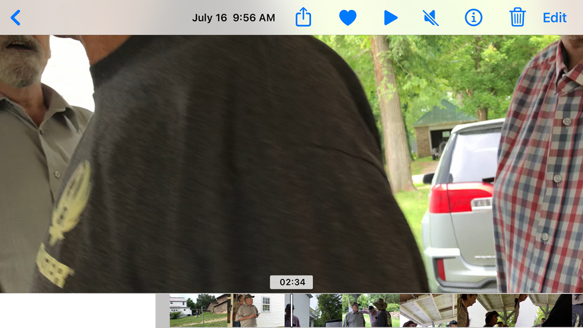
DAVE CAMPBELL: (to Randy Dunn) Well, then you did see him push on me, A**hole. You just said he was pushing me away. (02:35)
GARY DUNN: I was trying to get to her. (02:35)
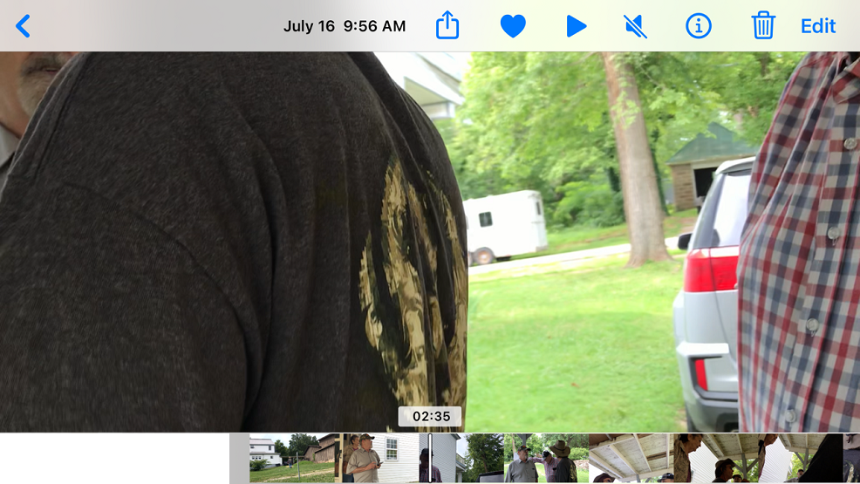
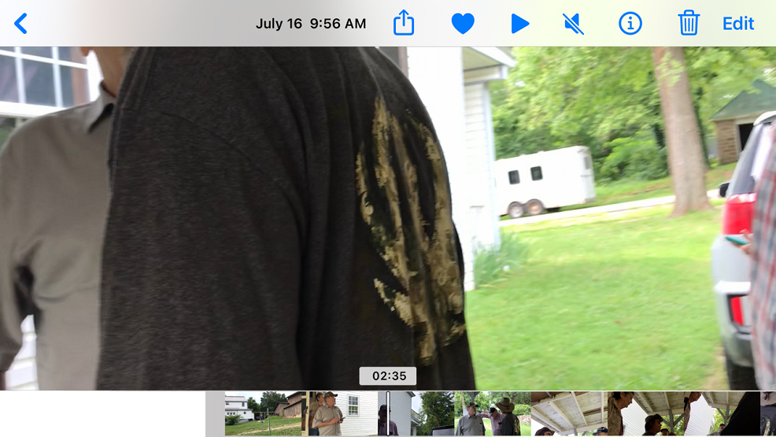
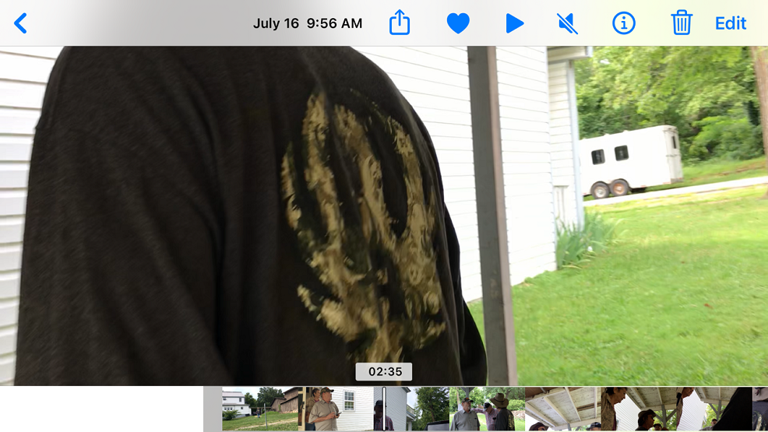

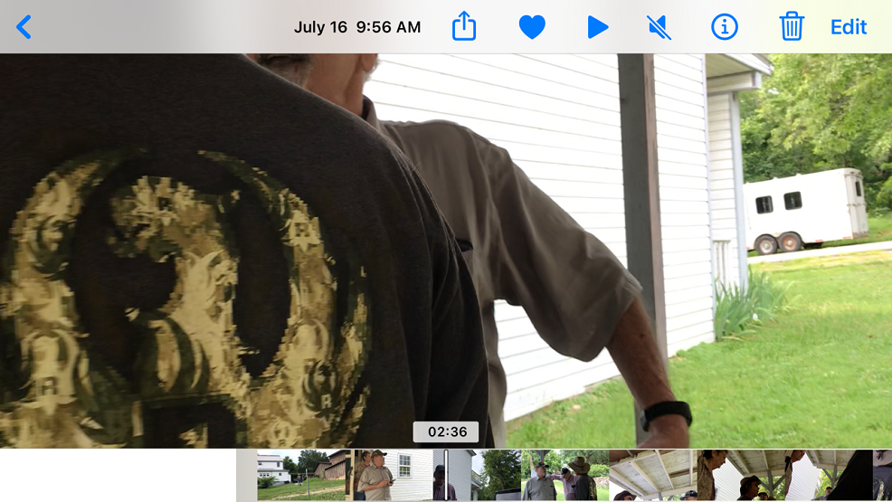

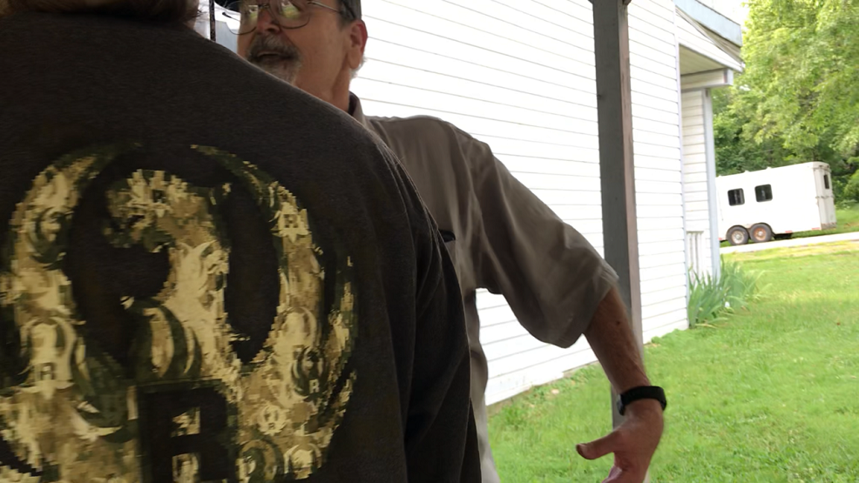
RANDY DUNN: No, I didn’t say it. You’re not putting words – (02:37)

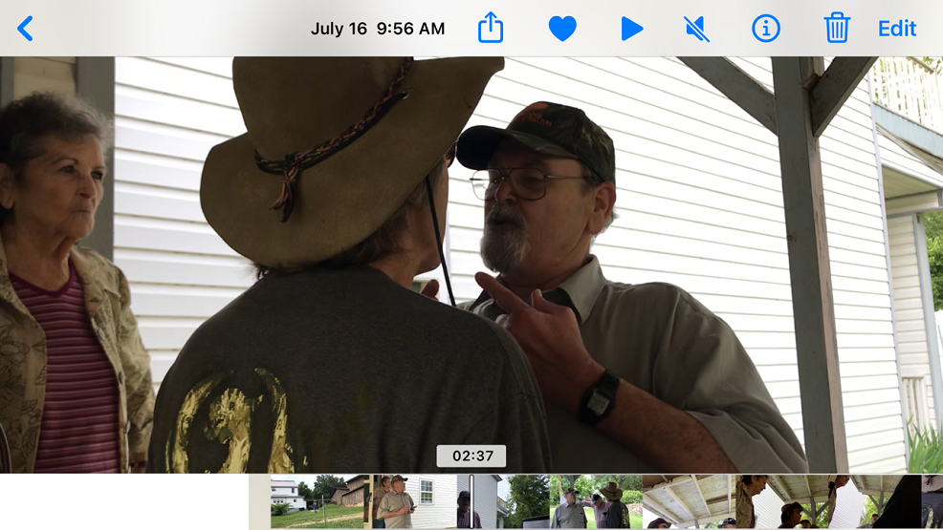
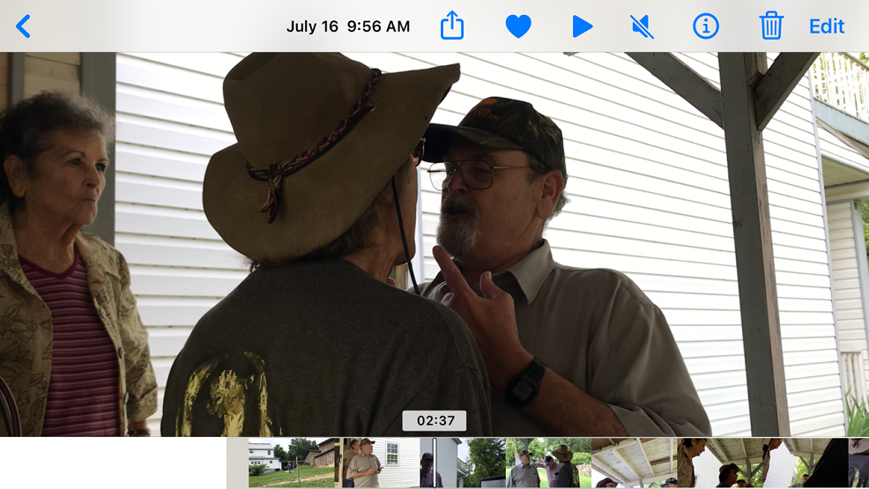

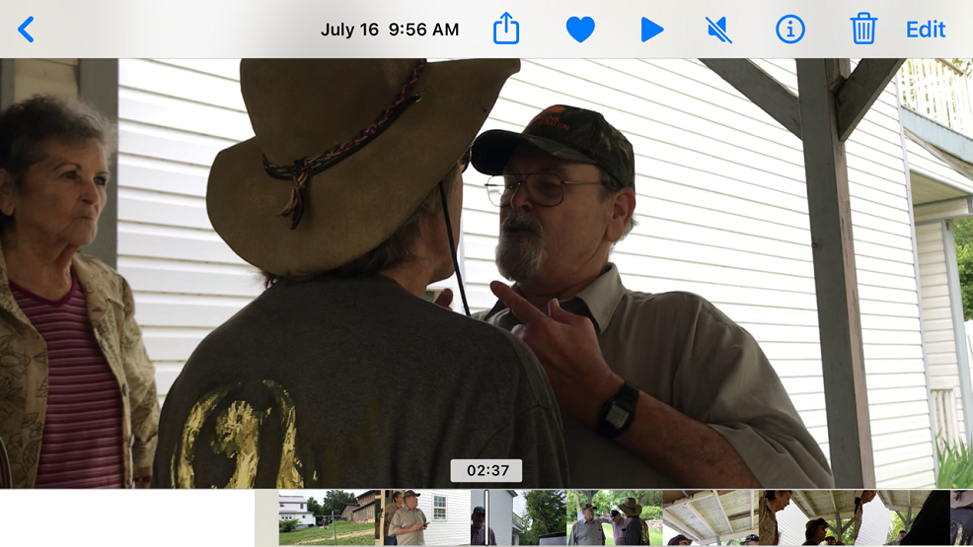
DAVE CAMPBELL (to Randy Dunn): Back the f*** up. (02:38)
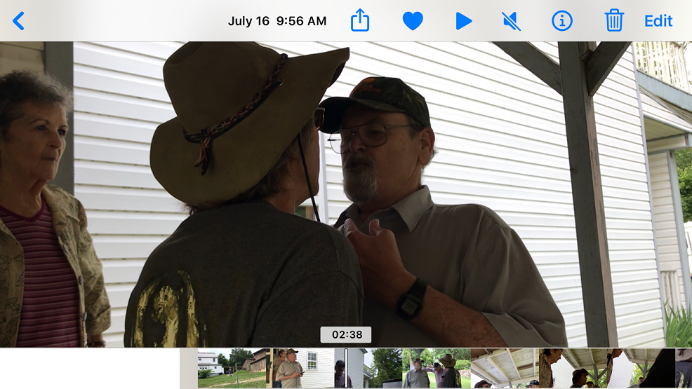
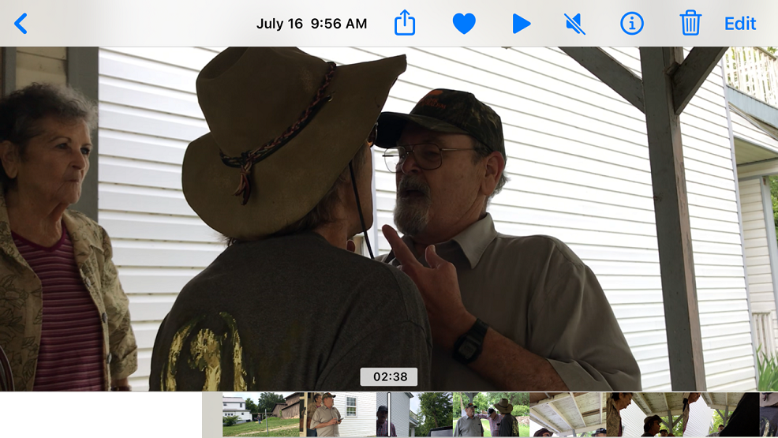
RANDY DUNN: You touched me this time. (02:39)
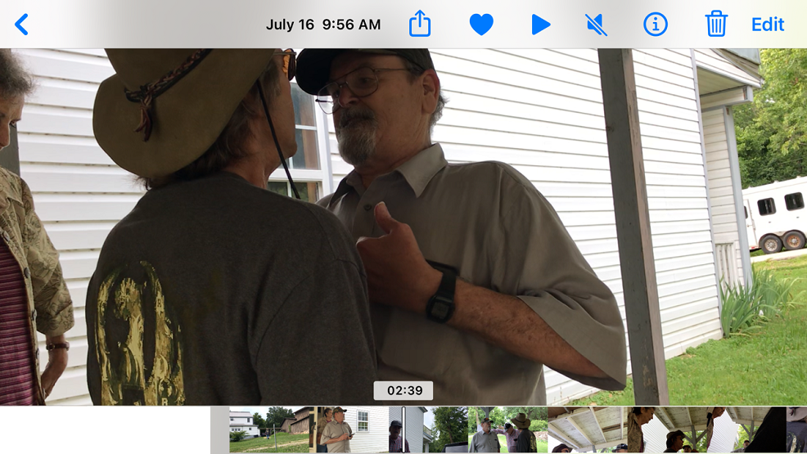
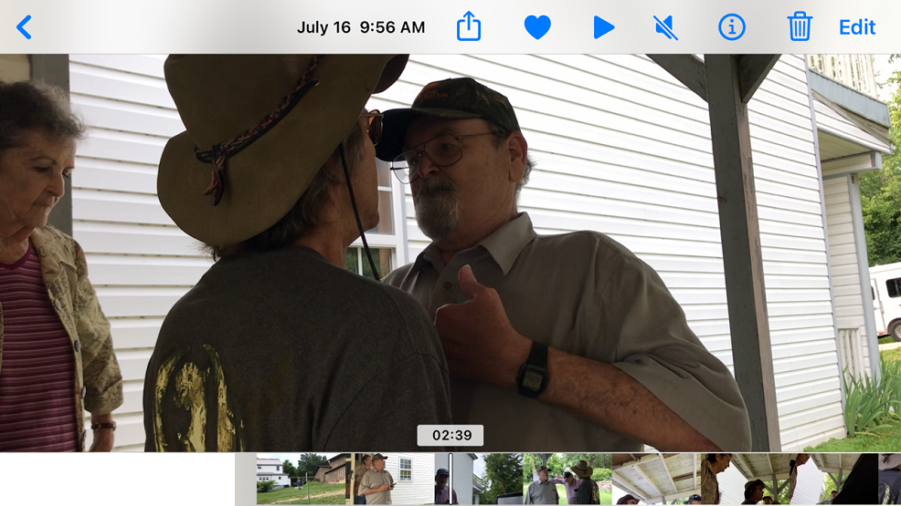
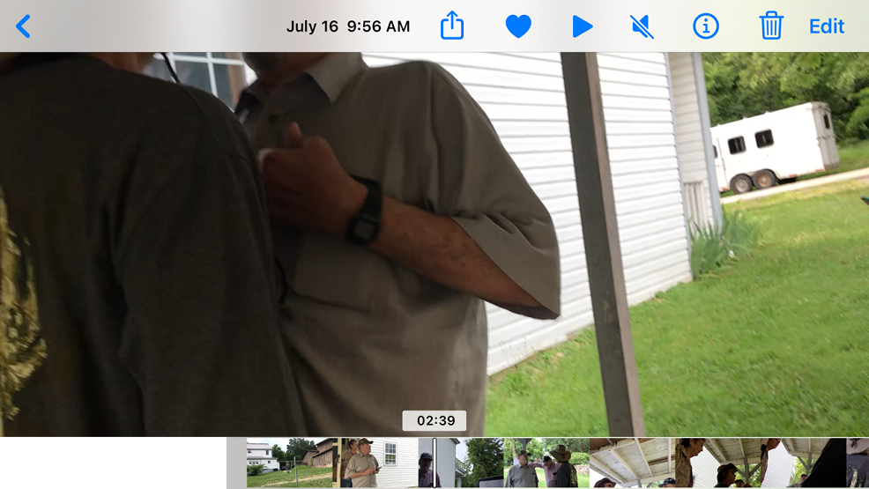
DAWN CAMPBELL: (to Randy Dunn) Listen. No. Stop. (2:40)
DAVE CAMPBELL: (to Randy Dunn) Get the f*** away from me. (02:40)
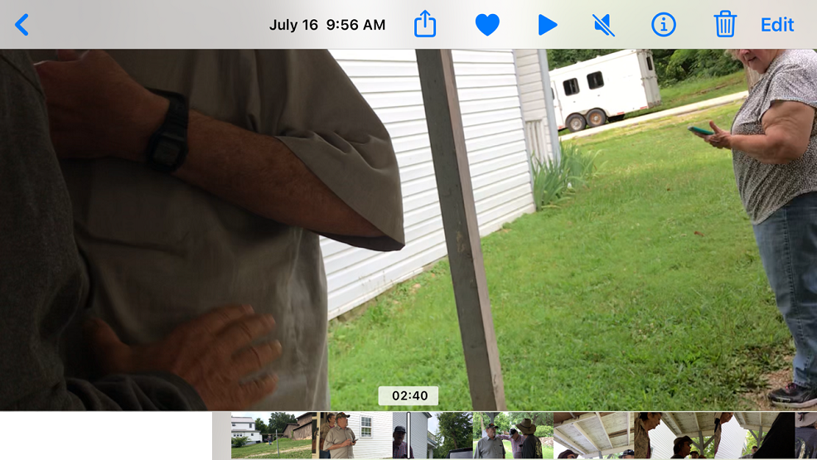
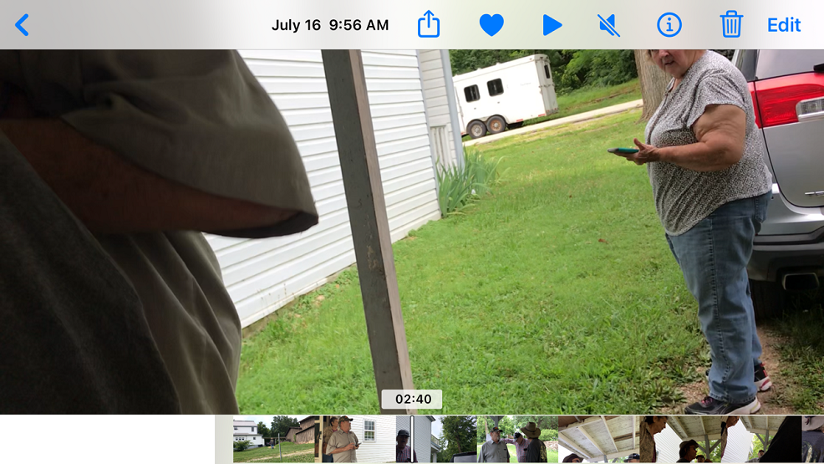
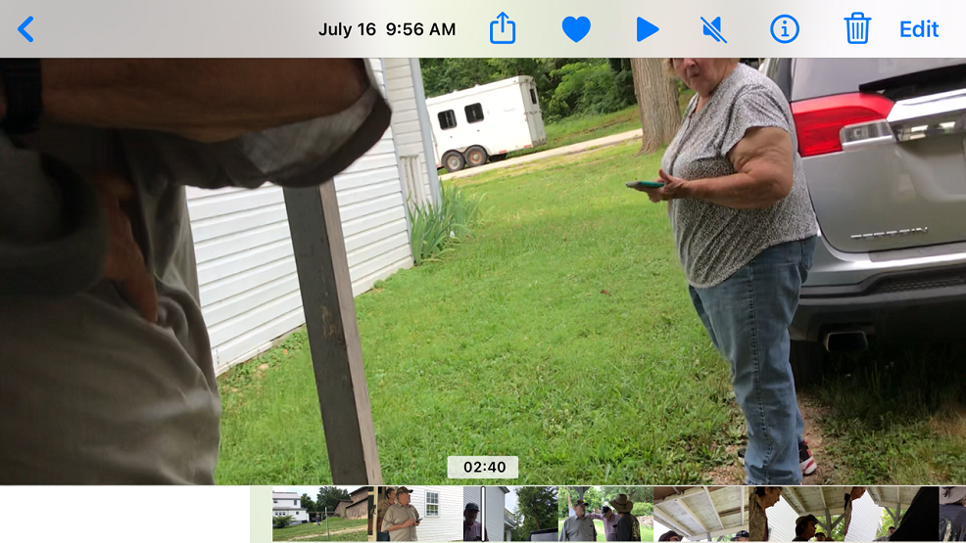
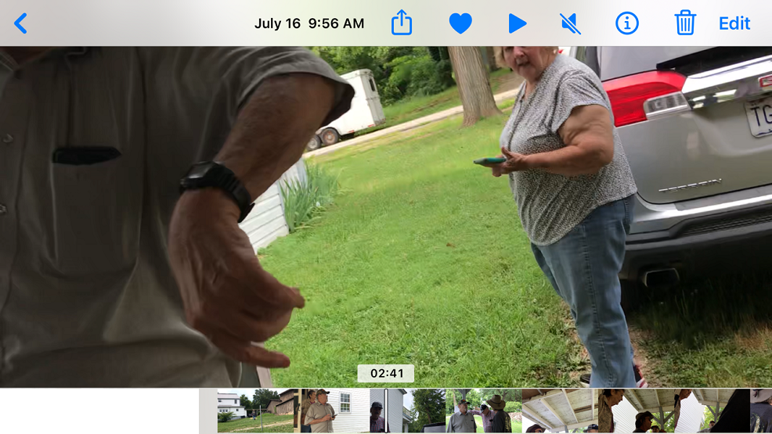
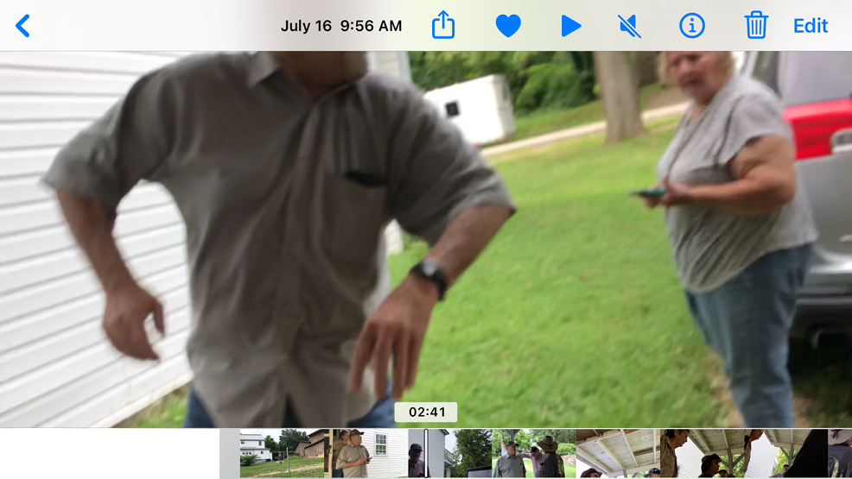
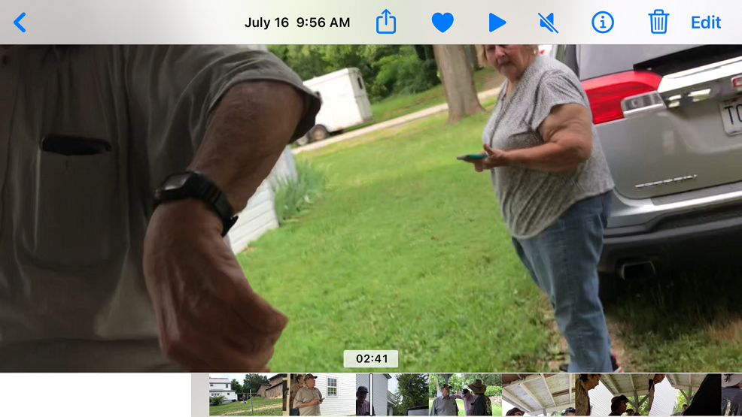
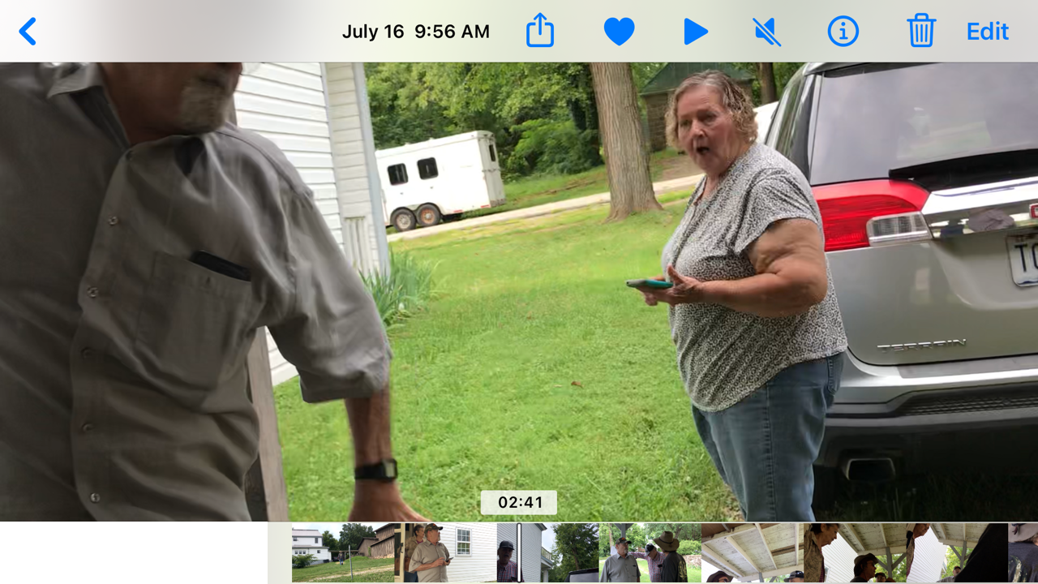
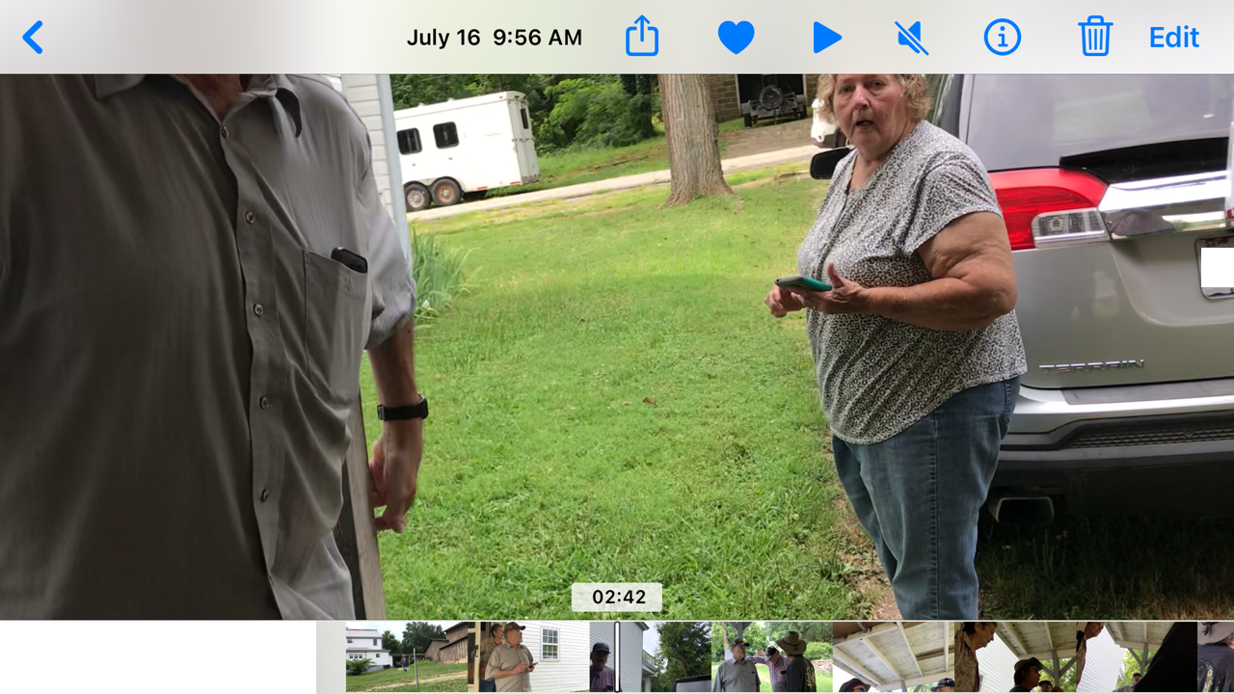
GARY DUNN: Brenda, get in the car and get down there in a hurry. (02:42)
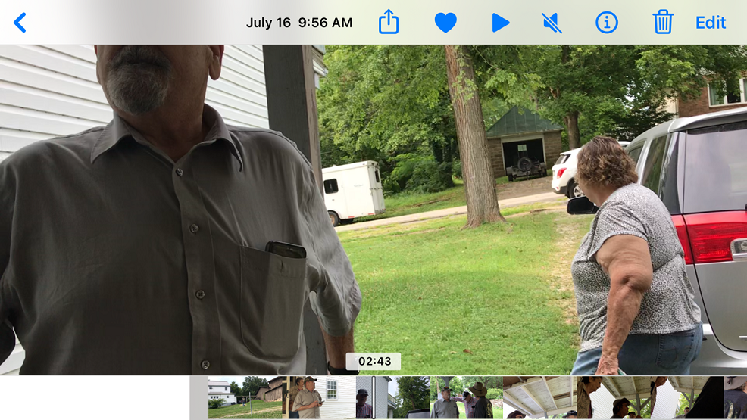
DAVE CAMPBELL: (to Randy Dunn) Get the f*** away from me. (02:44)
DAWN CAMPBELL (to Randy Dunn): Randy, stop hitting my husband. (02:44)
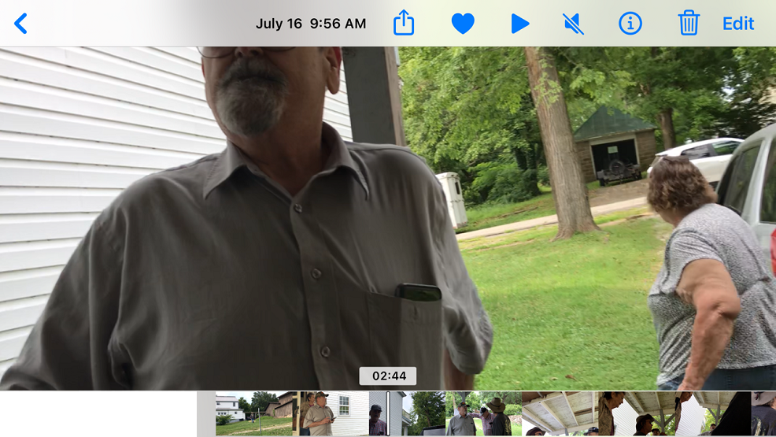
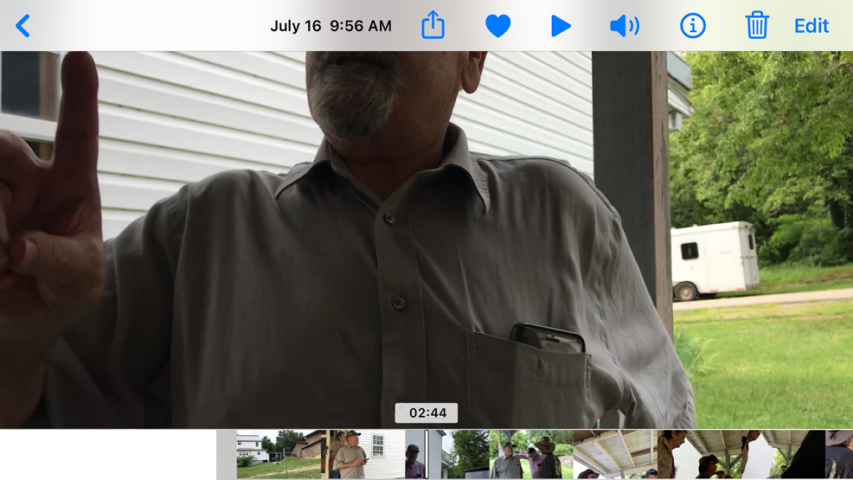
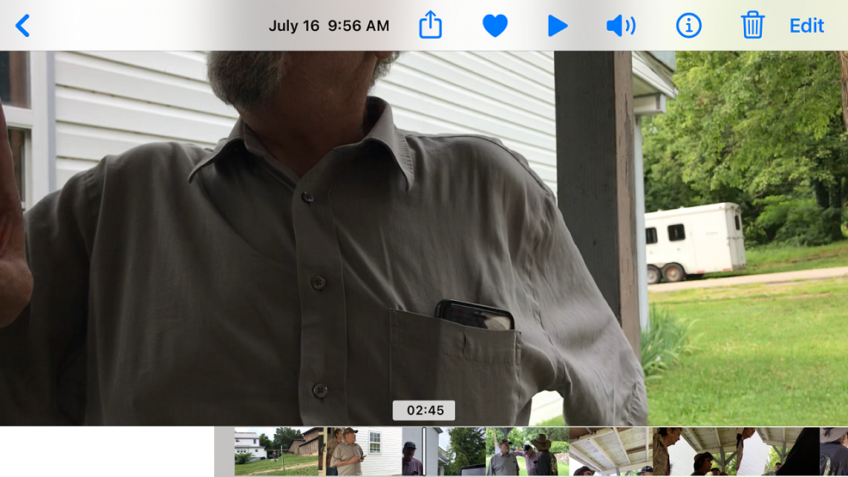
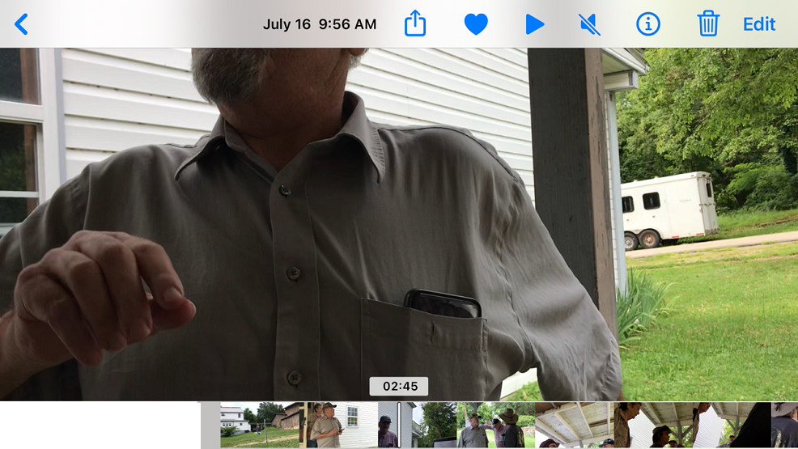
DAVE CAMPBELL: (to Randy Dunn) You keep touching me and I’m gonna kick your ass. (2:46)
RANDY DUNN: I didn’t touch you. (02:46)
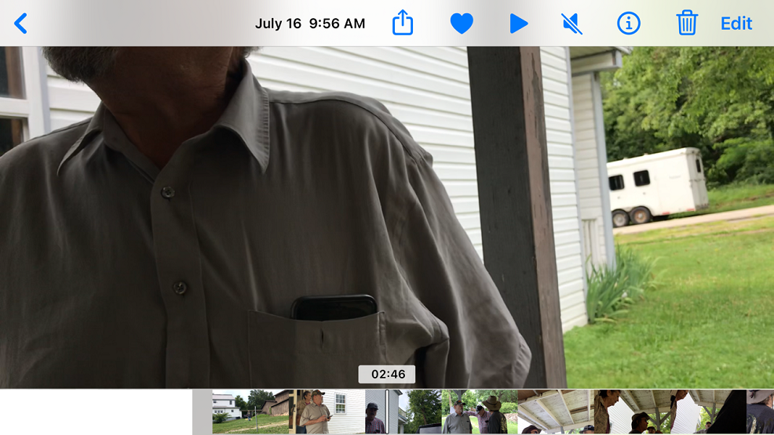
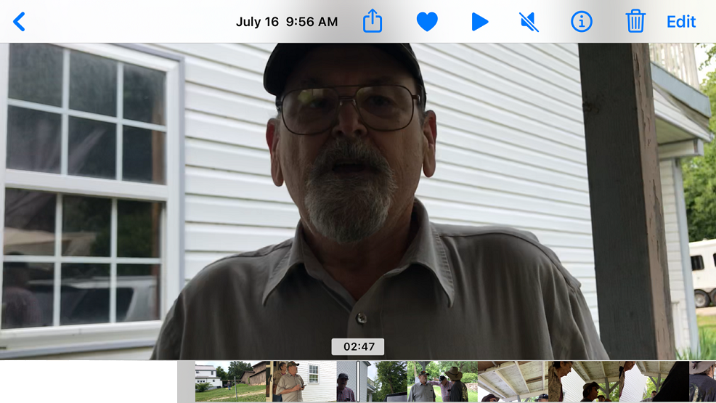
DAWN CAMPBELL: (to Randy Dunn) Yes, you did. I saw you. (02:48)
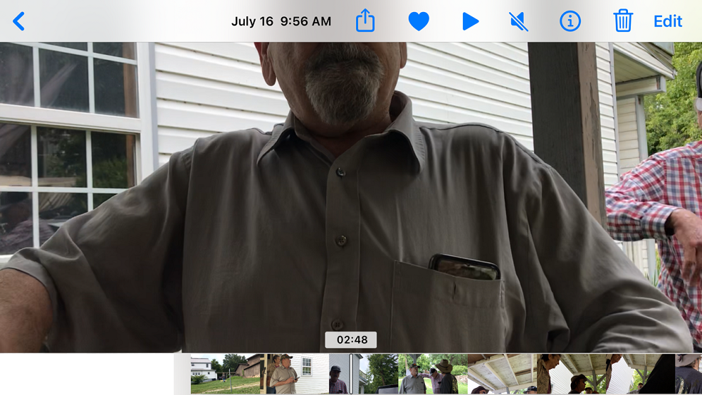
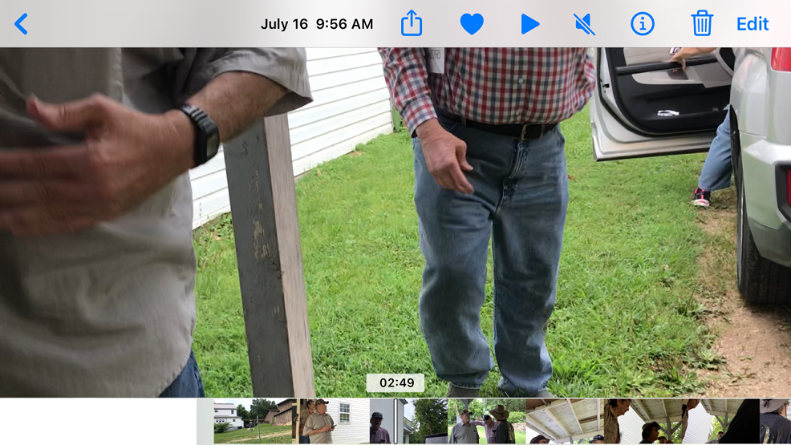
DAVE CAMPBELL: You put your fat ass up against mine. You backed up against me. (2:50)
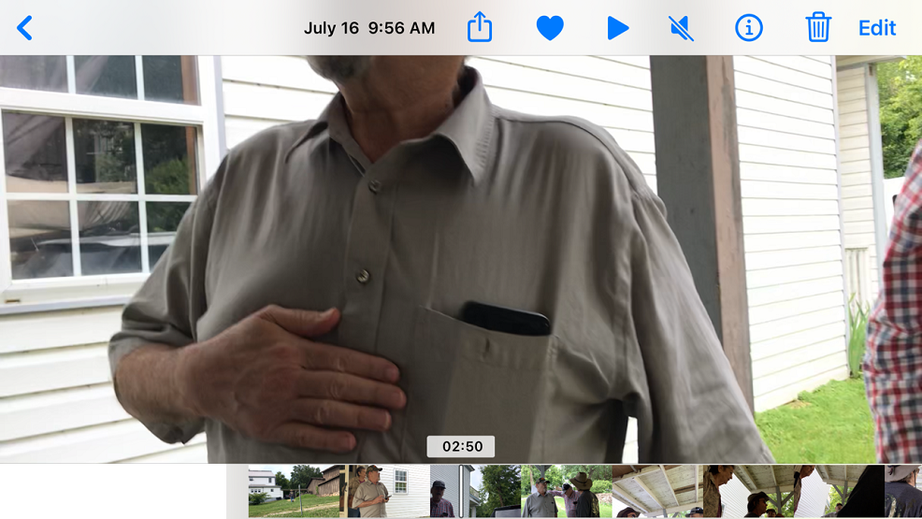
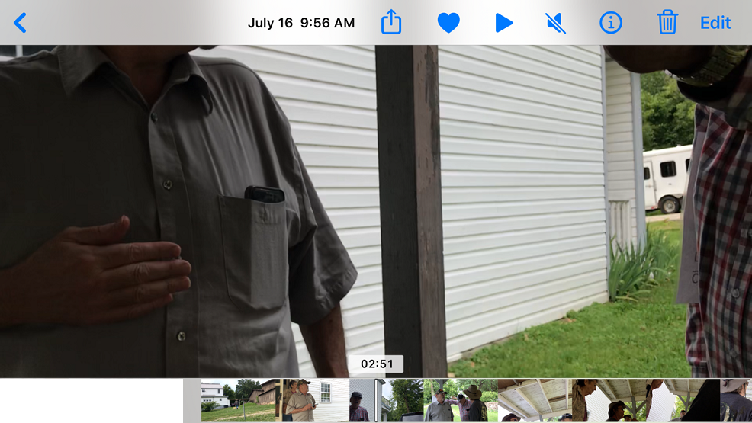
RANDY DUNN: No, you walked up against me. (02:51)
DAWN CAMPBELL: (to Randy Dunn) Yes, you did. I’ve got you on camera and you need to calm down. (02:53) <-(The arrest affidavit falsely alleged I said this to Dave.)
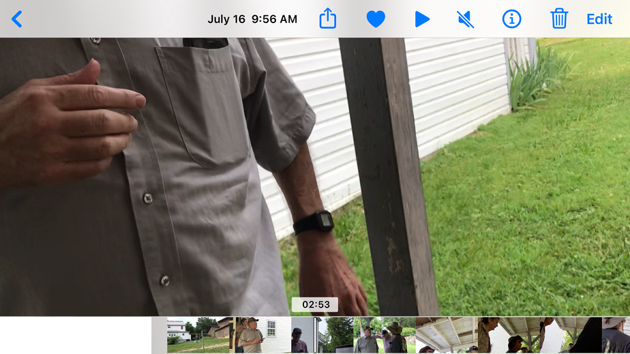
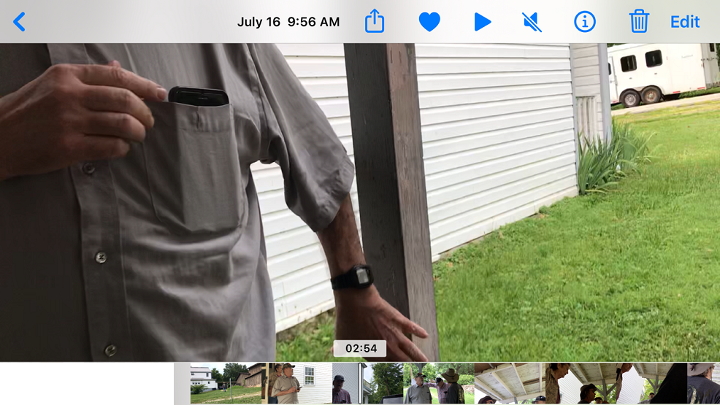
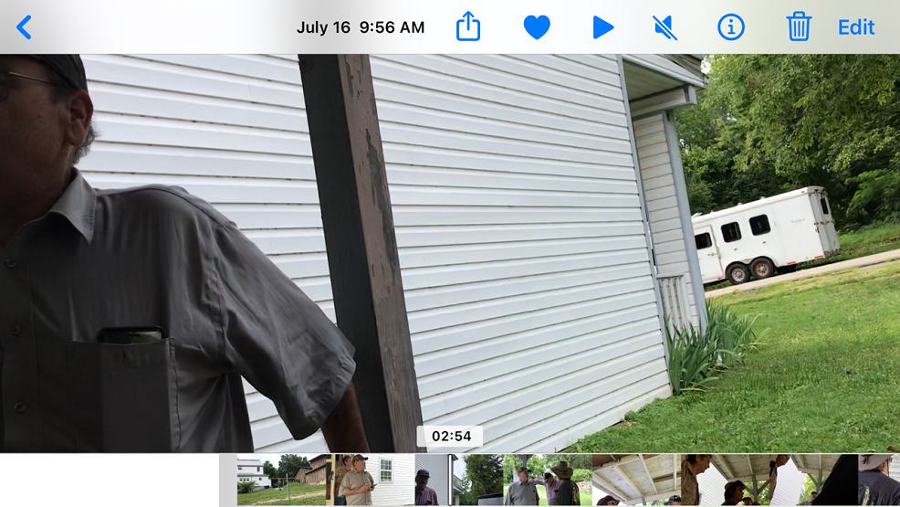
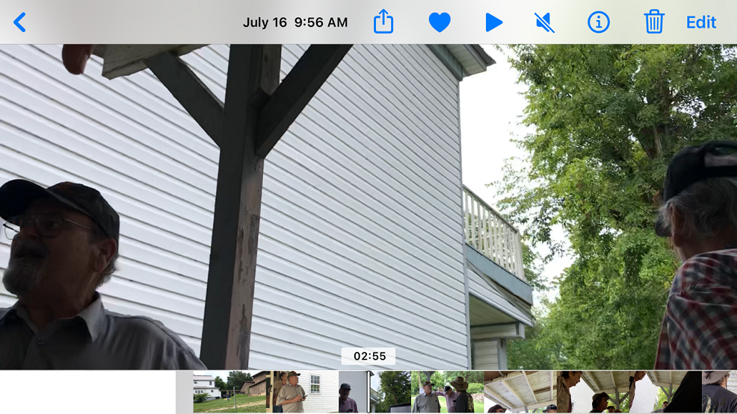
GARY DUNN: Brenda’s going to the City now. (02:56)
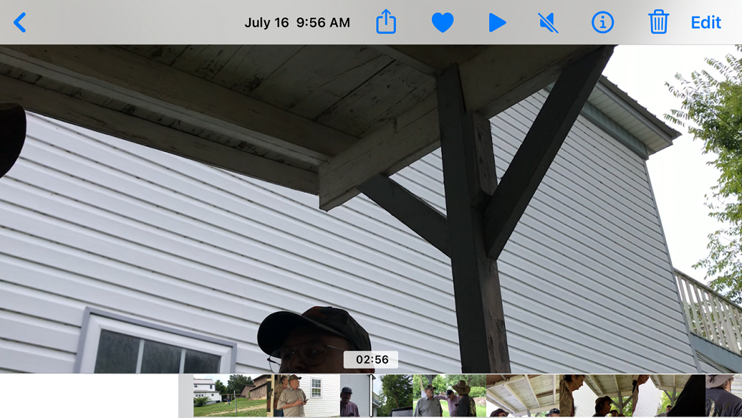
DAVE CAMPBELL: Right here, Dude. (02:57)
RANDY DUNN: You pushed up right up to me. (02:57)
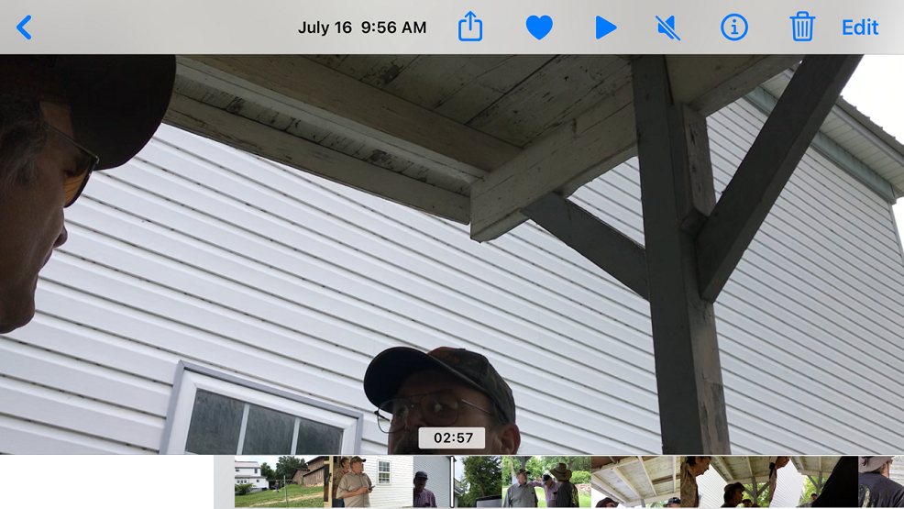
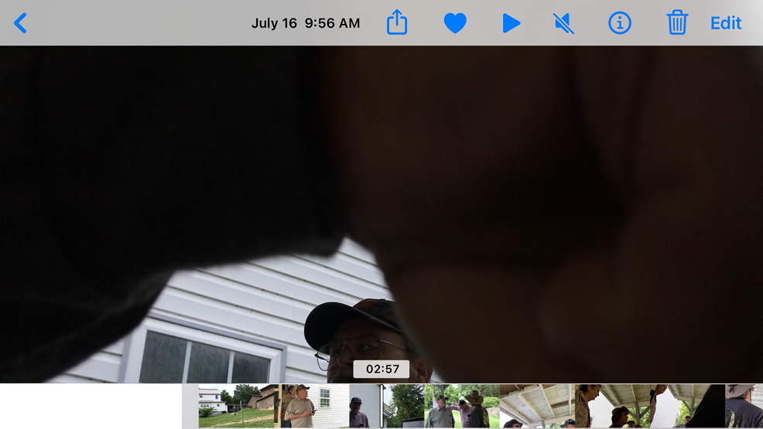
DAVE CAMPBELL: Right here on film. (2:58)
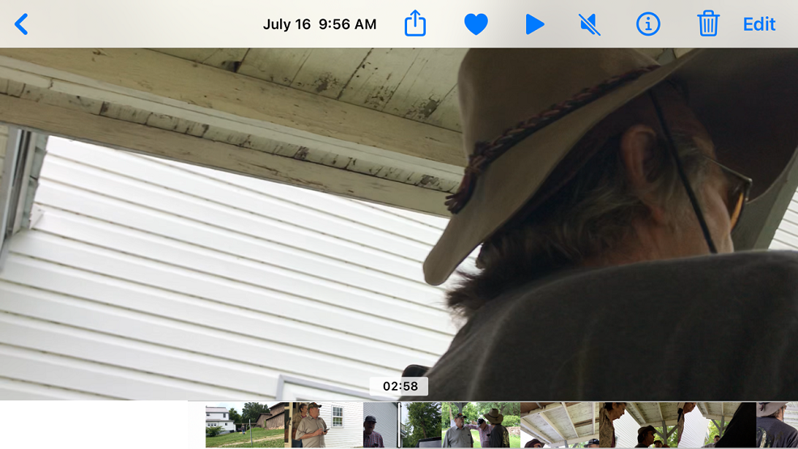
BETTY DUNN: All of you leave. [02:59]
DAWN CAMPBELL: Get. Get. [02:59]
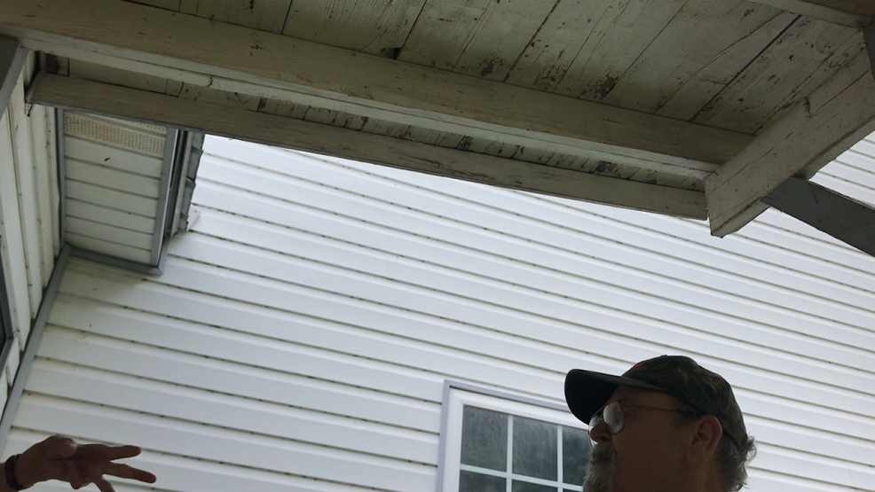

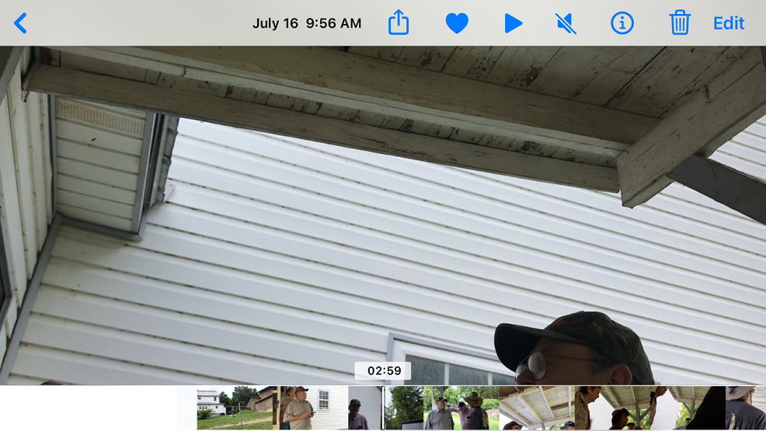
RANDY DUNN (to Betty Dunn): Huh?
DAWN CAMPBELL: Get out of here. (3:00)
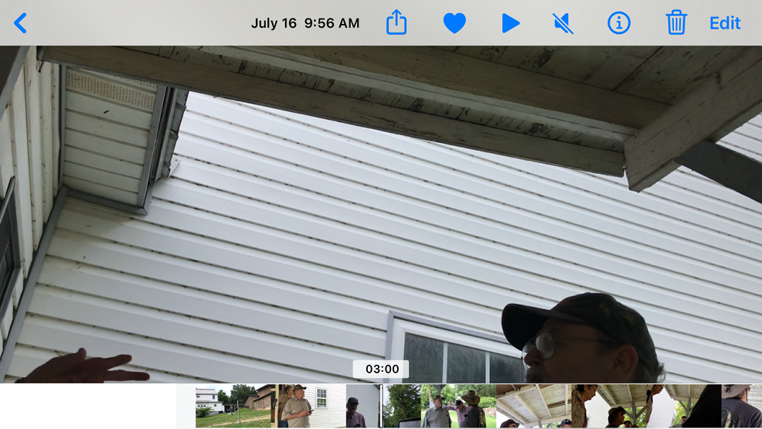
BETTY DUNN: This is my house. (03:01)
DAWN CAMPBELL: Ran -- Betty said to leave and you need to leave. (03:01)
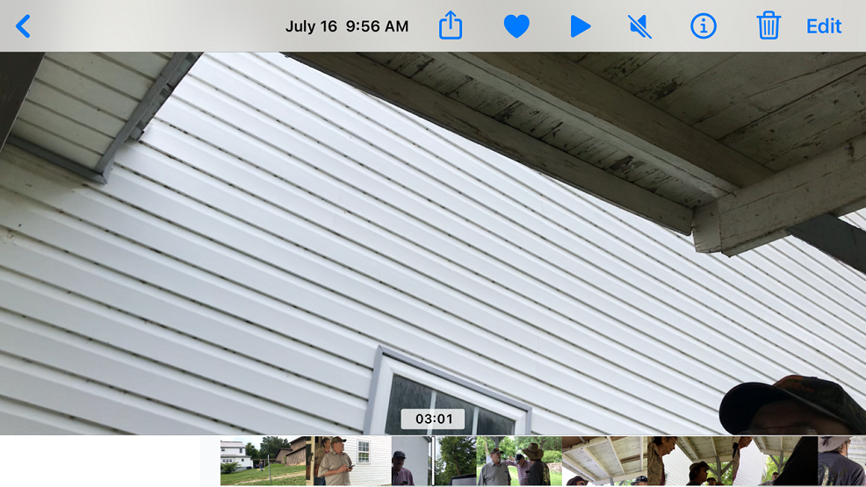
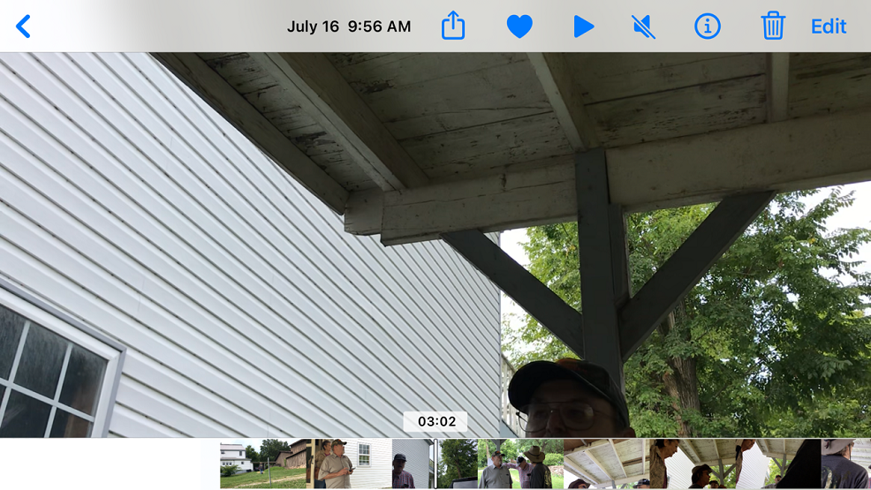
BETTY DUNN: This is my house. (03:03)

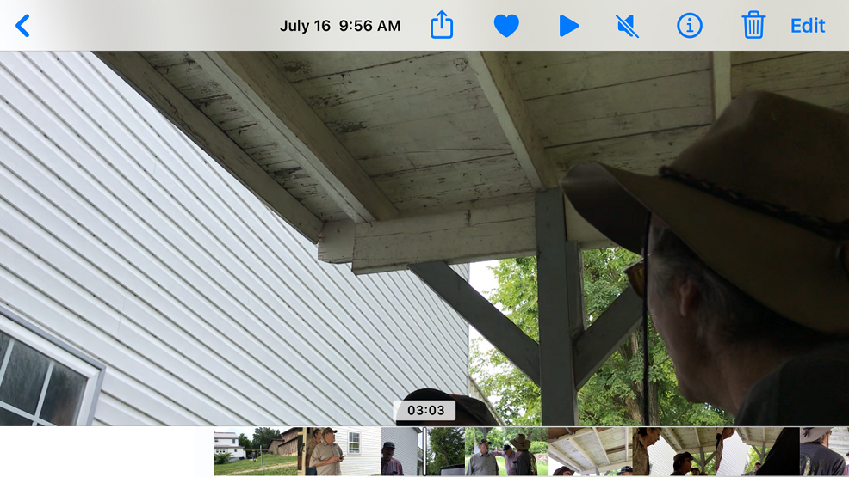
DAVE CAMPBELL: She’s telling you to get off her property.(03:04)
DAWN CAMPBELL: Leave. Leave. (03:04)
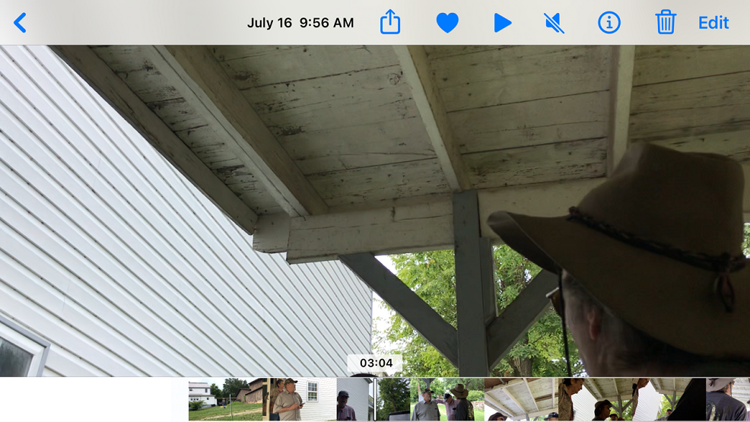
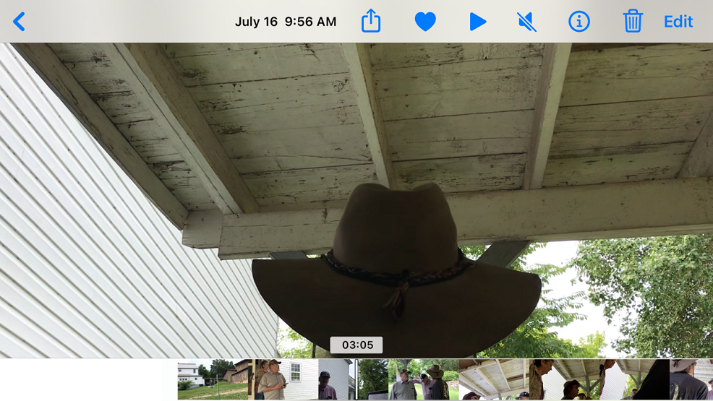
RANDY DUNN: We can come in and inspect this house anytime we want to. (03:07)
DAWN CAMPBELL: (to Randy Dunn) You will not. (03:08)
CERTIFICATE OF TRANSCRIPTION
I, Catrenia Dawn Campbell, served as a Certified Shorthand Reporter for the State of Oklahoma. This transcript was created to the best of my ability and is taken from a video recording I made at 435 Bethel Avenue in Mammoth Spring, Arkansas on July 16, 2024. The numbers at the end of each statement are the approximate time of each statement’s ending. Many statements were stated at the same time. Some statements were indiscernible. To verify each statement, the video evidence is located at the following secure web link at You Tube:
https://youtu.be/iOXR0yjHgNM

Respectfully Submitted,

/s/ Catrenia Dawn Campbell
_________________________________
Catrenia Dawn Campbell 10/06/24

