Gary Dunn Attack 1
RANDY DUNN: You’re supposed to stay off this place.(00:04)
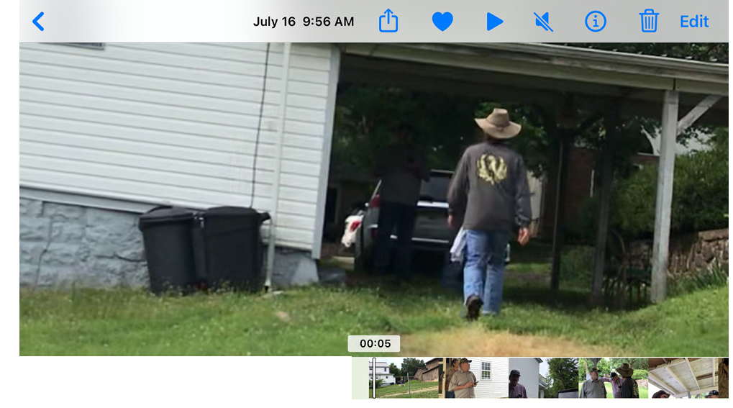
DAWN CAMPBELL: We want to check on Betty. (00:05)
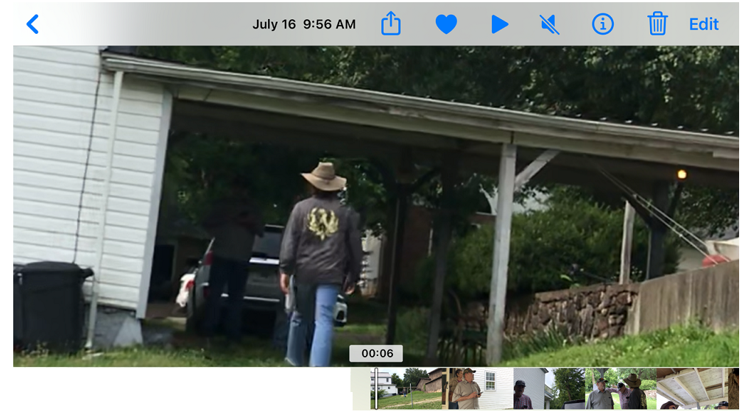
DAVE CAMPBELL: They’re on their way, A**hole. (00:06)
DAWN CAMPBELL: Betty is our friend. (00:07)
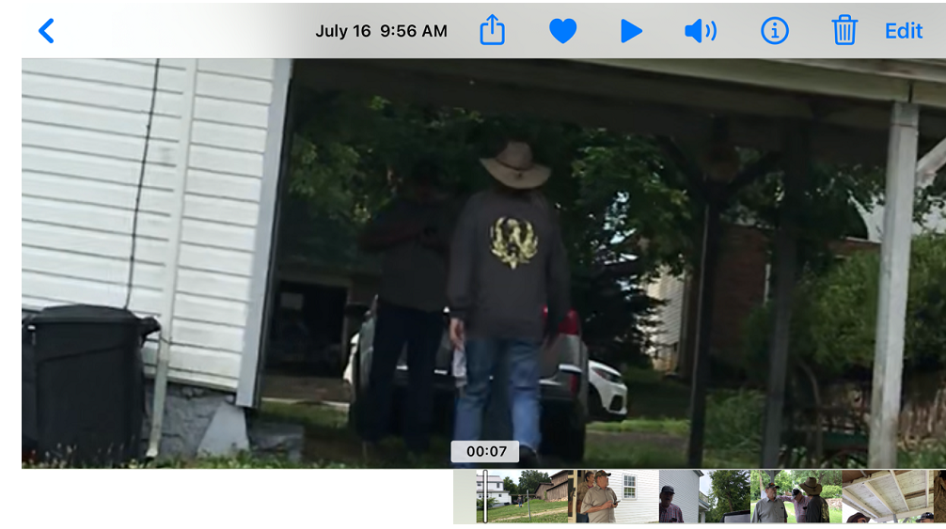
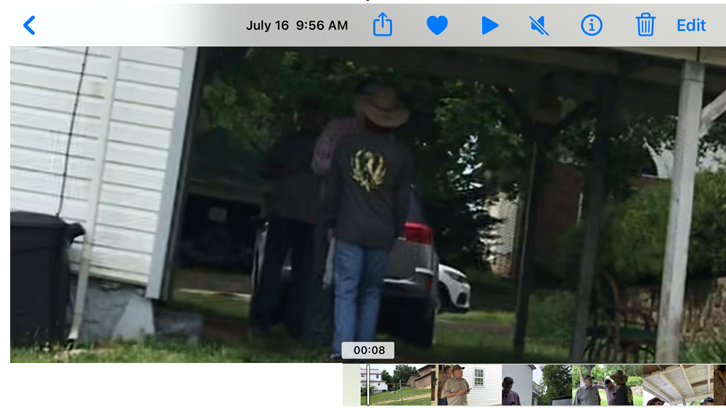
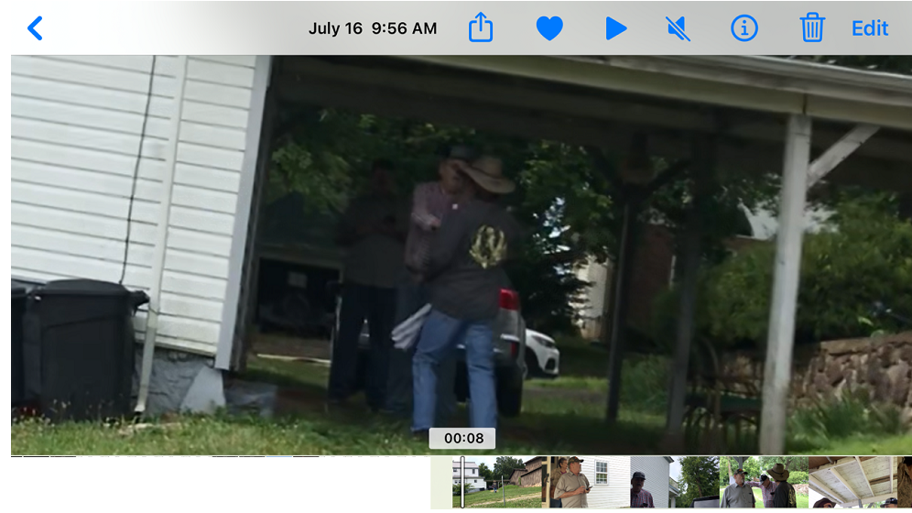
RANDY DUNN: No, she is not your friend. (00:08)
DAWN CAMPBELL (to Gary Dunn): HEY, HEY! (00:09)
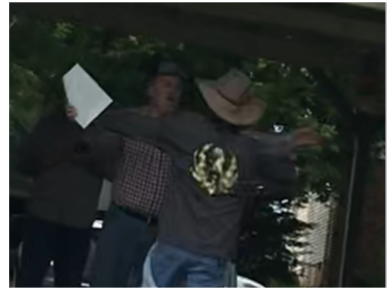
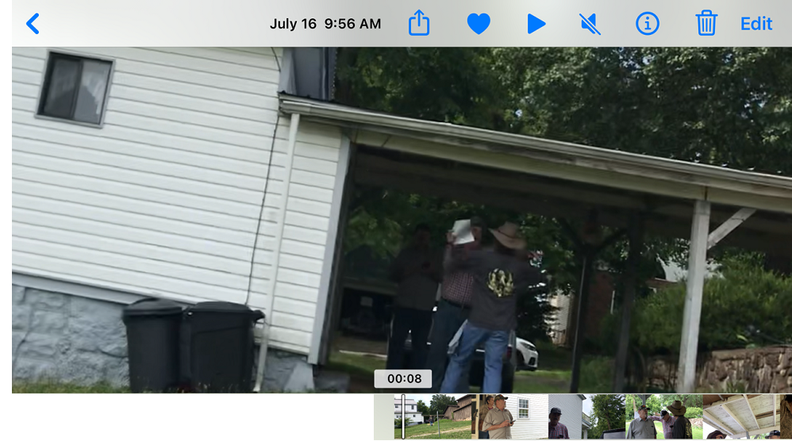
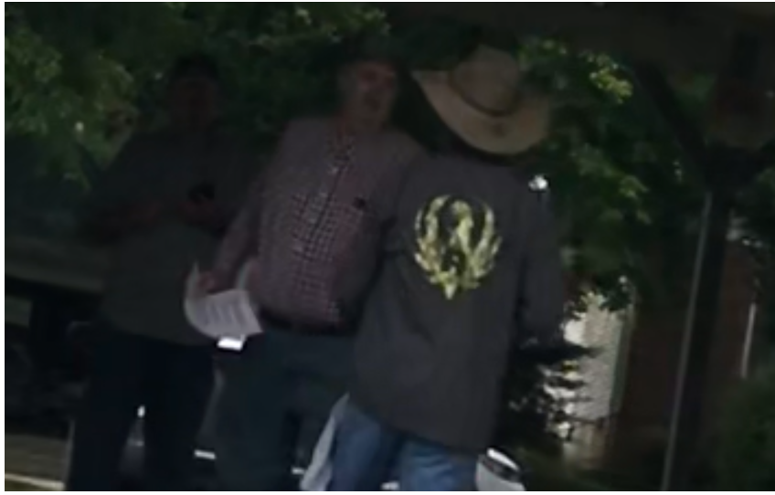
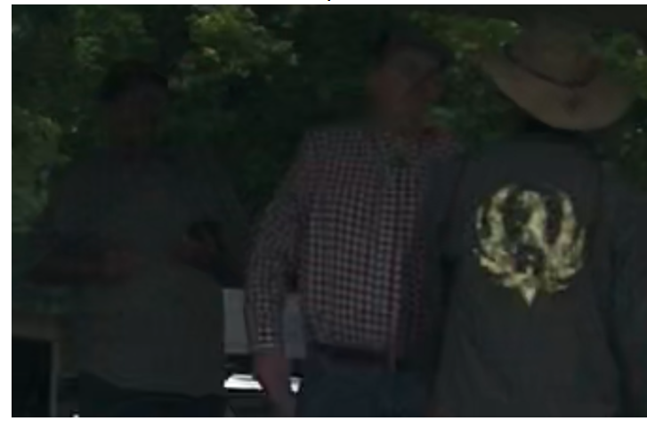
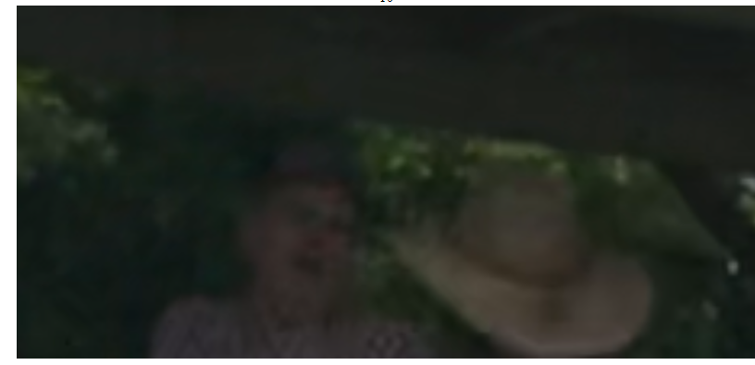
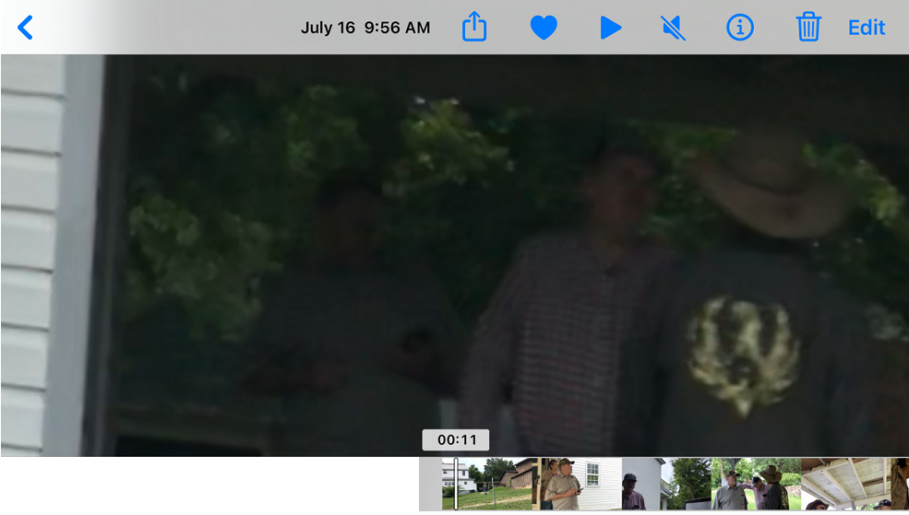
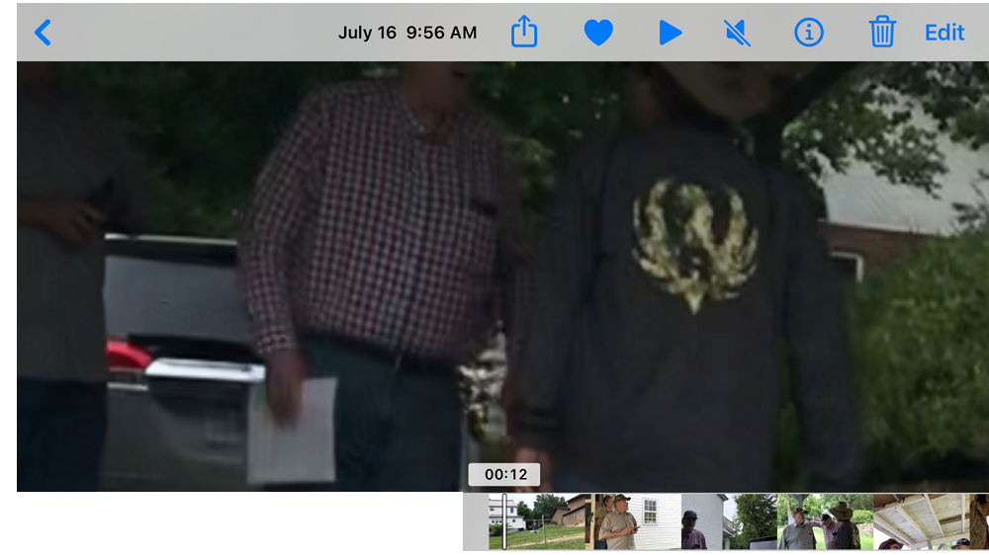
GARY DUNN: Don’t you come up here. You ain’t going to do nothing. (00:13)

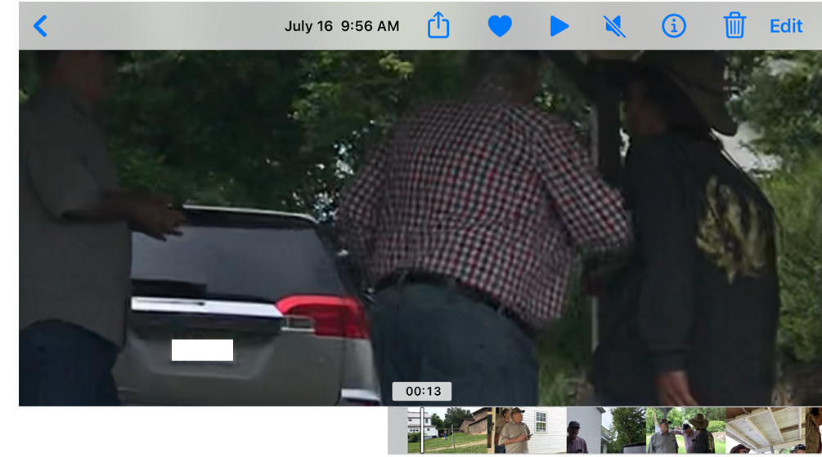
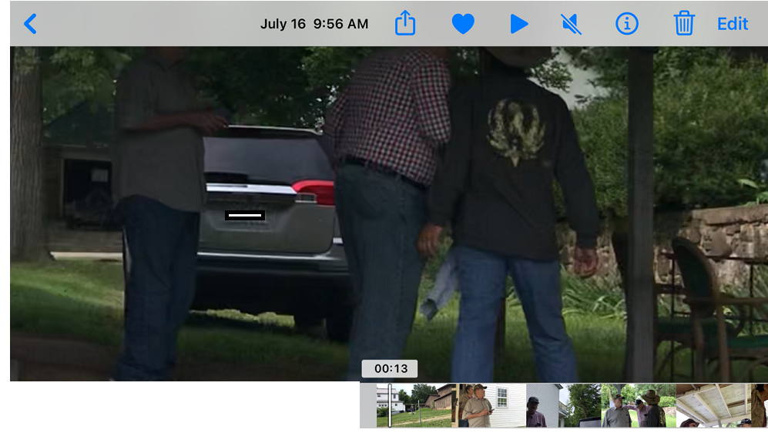

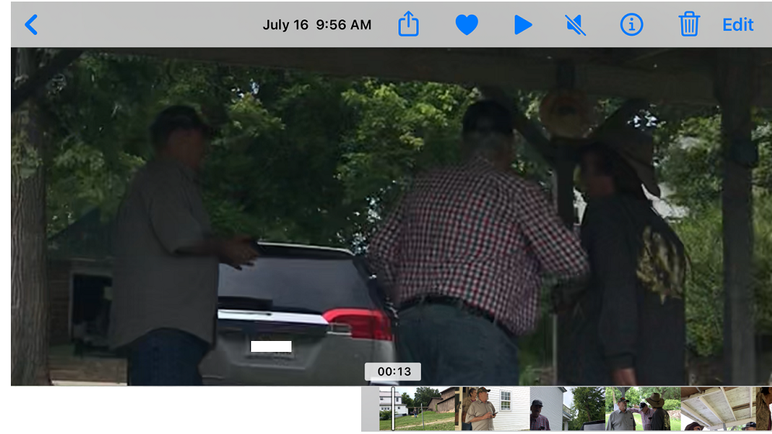
DAWN CAMPBELL: We are going to check on Betty. (00:14)
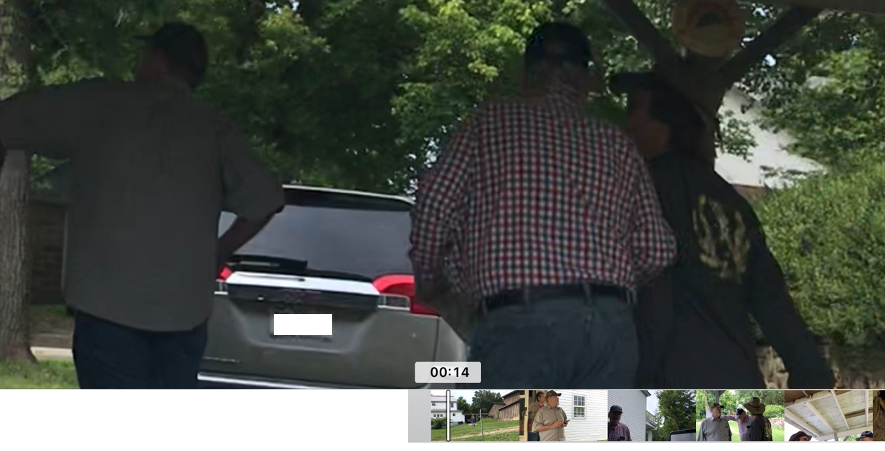
DAVE CAMPBELL: I am going to stand on the porch and the cops are on their way. (00:15)
GARY RANDY: Not on the porch.
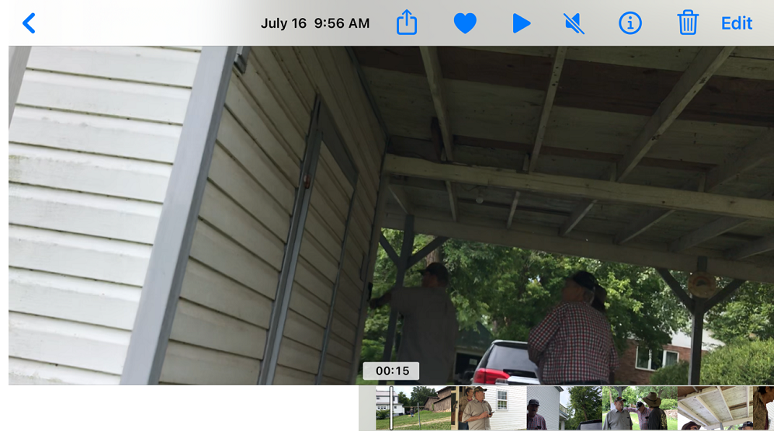
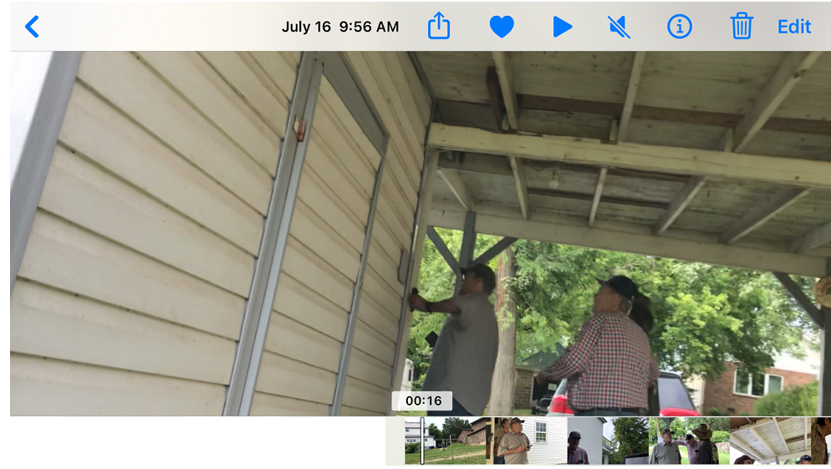
DAWN CAMPBELL (to Gary Dunn): Hey, get off of him. (00:18)
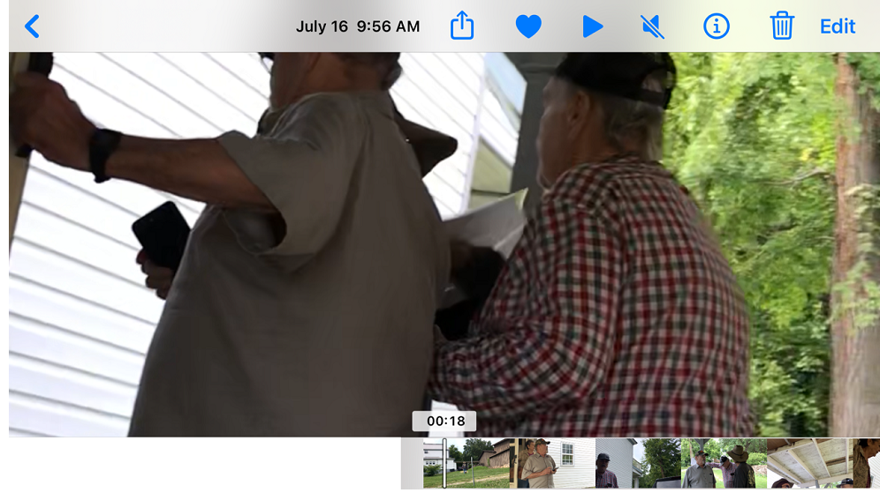
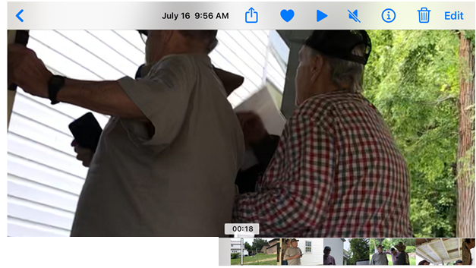
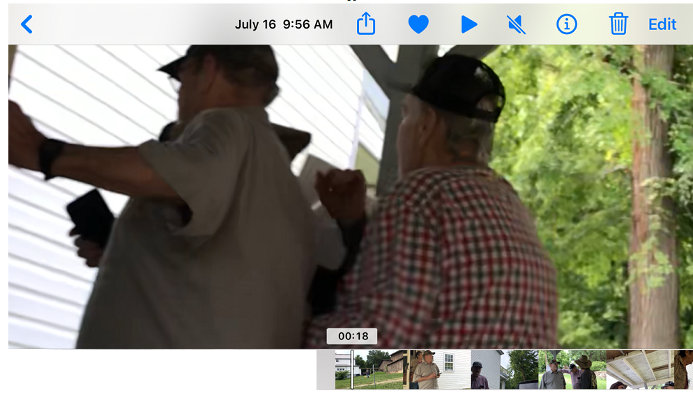
(Gary Dunn pushed on Dave for approximately 10 seconds – from 00:08 to 00:18.)
DAWN CAMPBELL (to Gary Dunn): Hey, get off of him. (00:18) 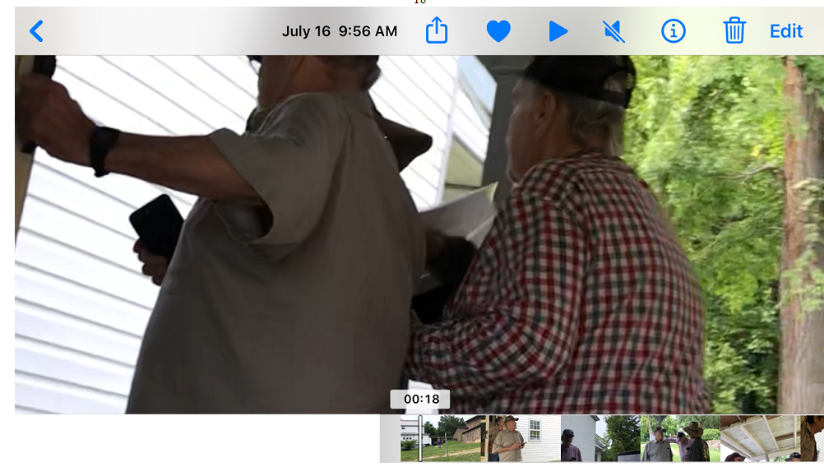 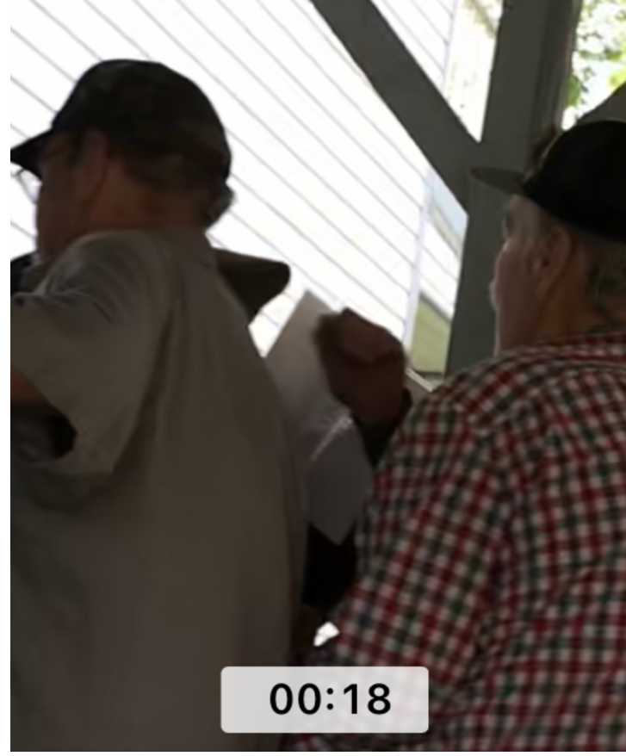
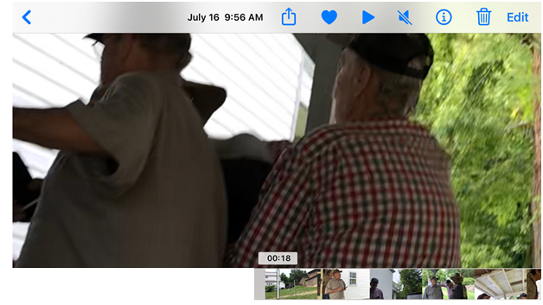
(Note: Gary’s arm is on Dave’s back.)
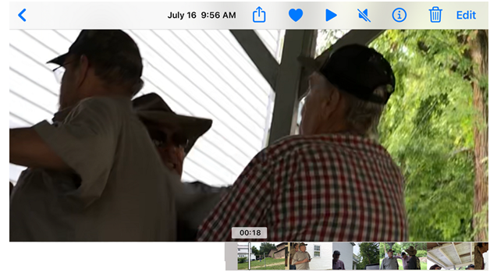
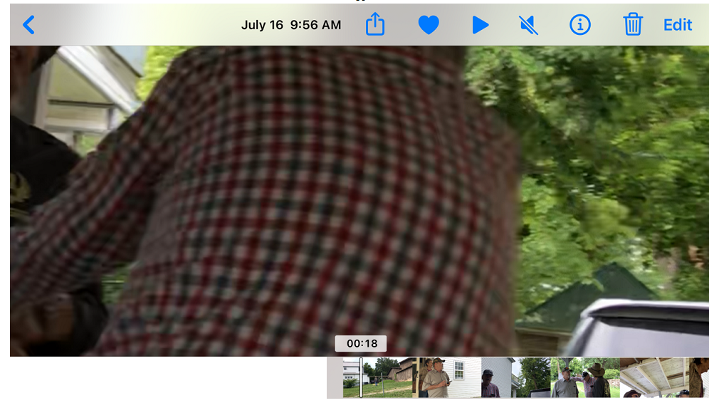
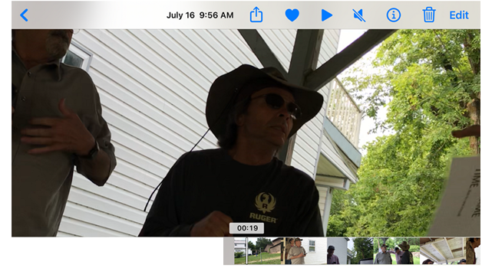(Gary did not seem fazed and continued to wave his finger and stolen sign.) (0:19)
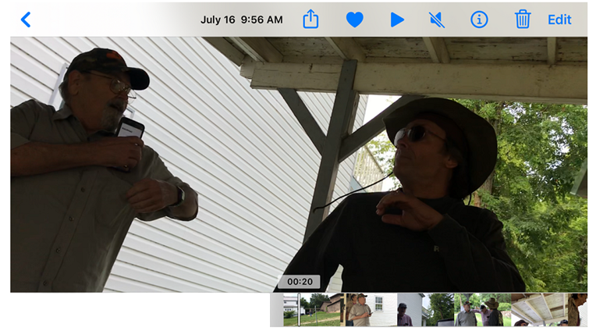
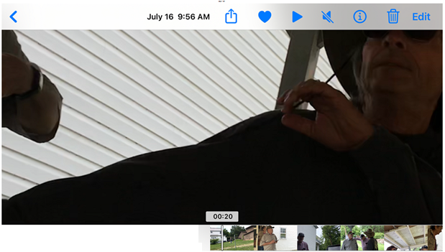
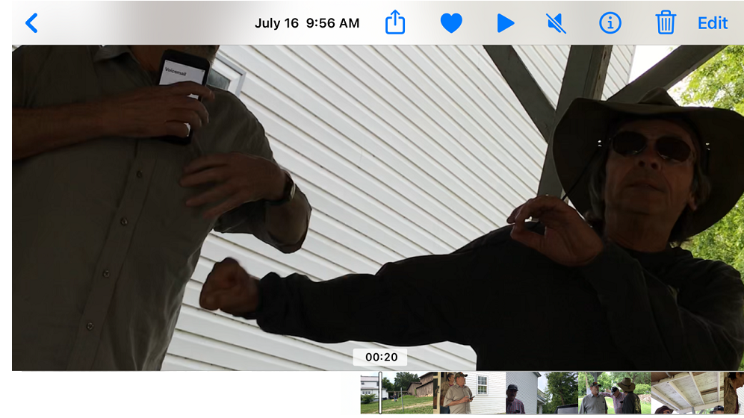
GARY DUNN: He hit me. That’s assault. (00:21)
DAWN CAMPBELL: He did not. (00:21)
DAVE CAMPBELL: He pushed me. (00:21)
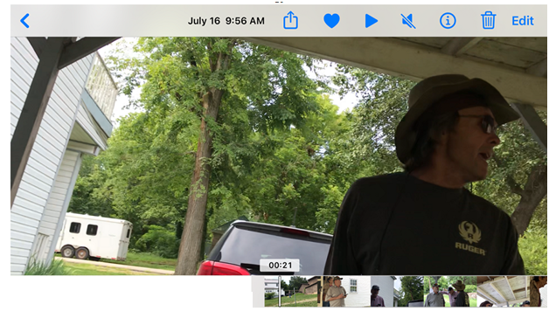
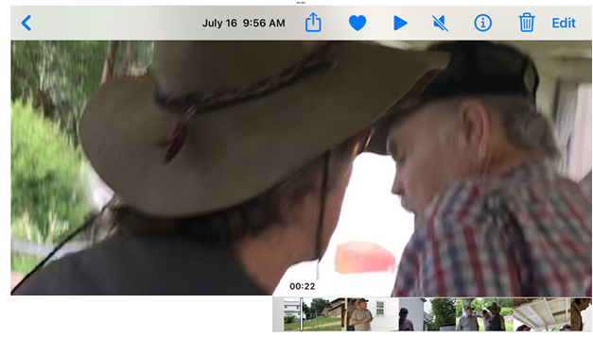
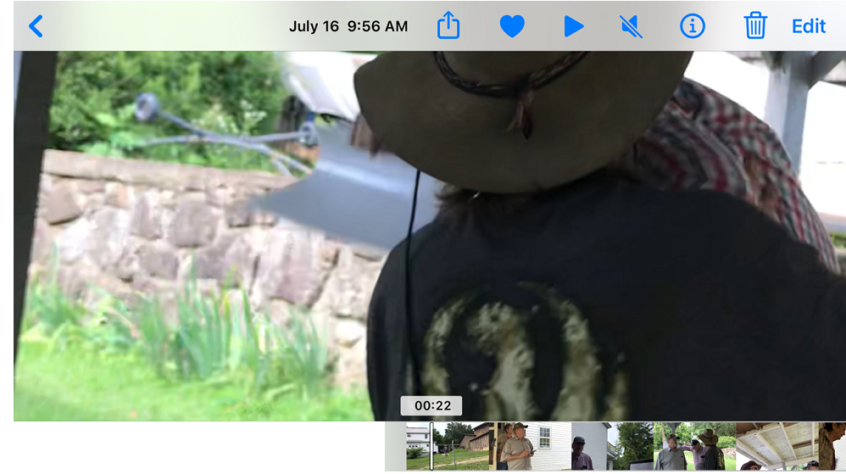
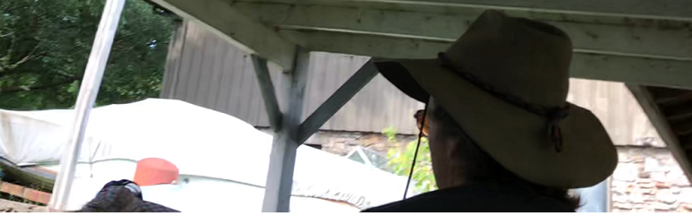
^( Gary Dunn is seen falling.)^ (00:23)
DAWN CAMPBELL: Dave. (00:23)
RANDY: Now, he’s gonna go to jail. (00:23)
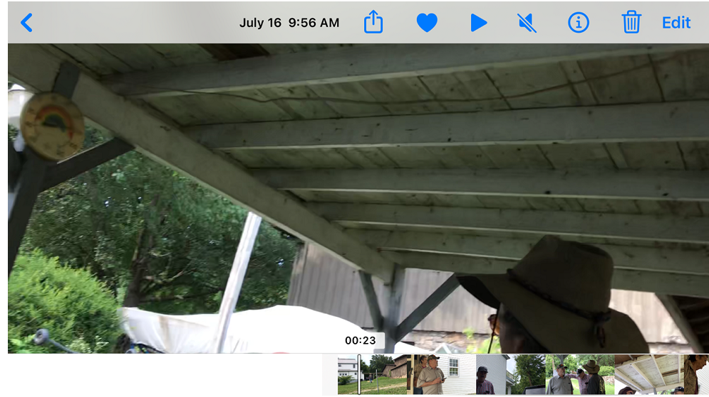
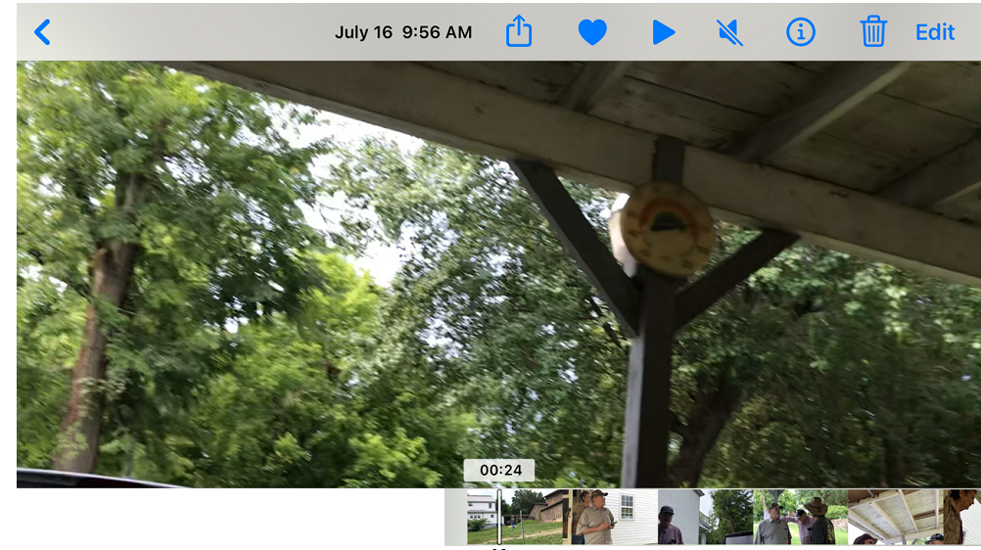
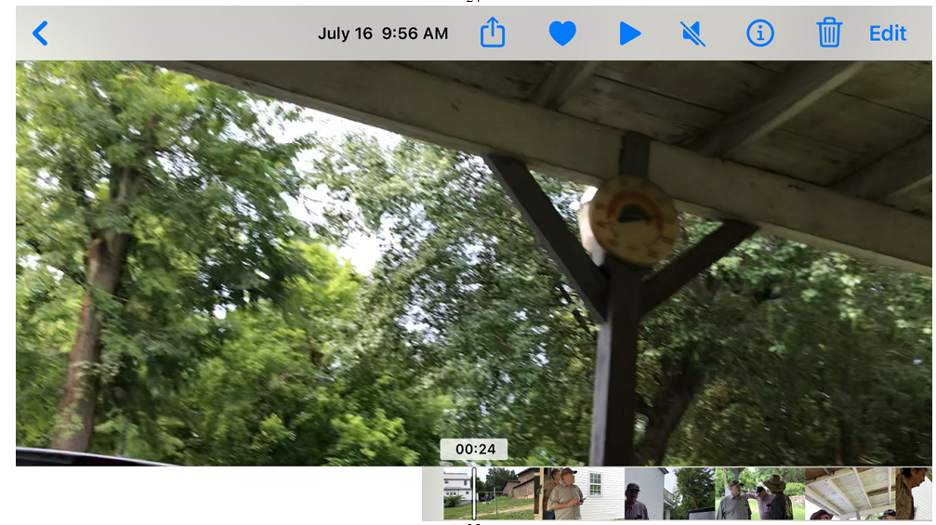
DAWN CAMPBELL: Dave, leave him alone. (00:24)
DAVE CAMPBELL: Yeah, you betcha I hit you; you’re a little a**hole. (00:24)
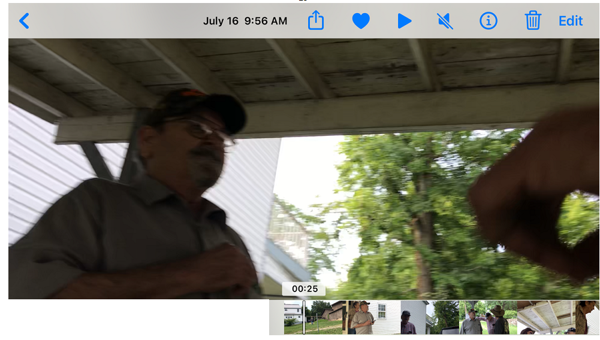
RANDY DUNN: Now, he’s gonna go to jail. (00:25)
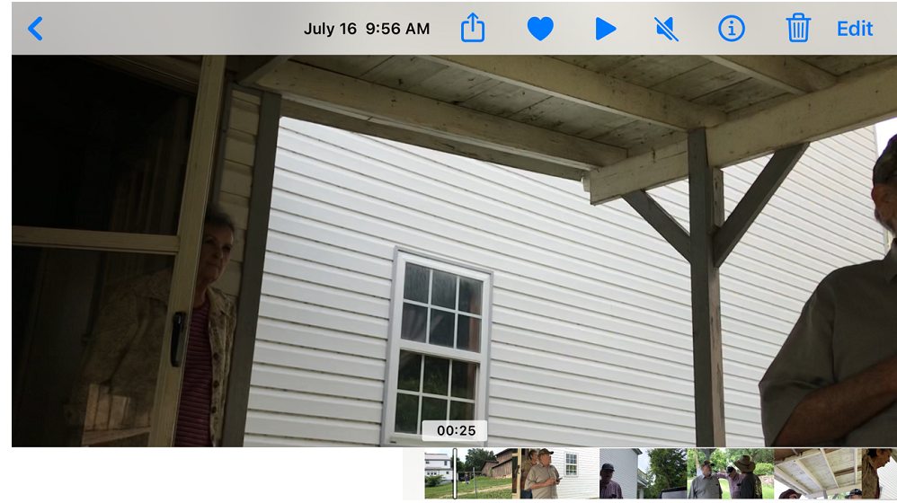
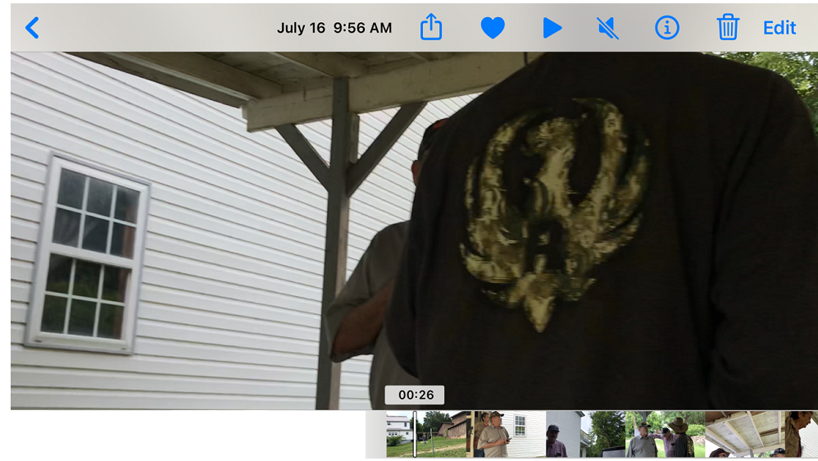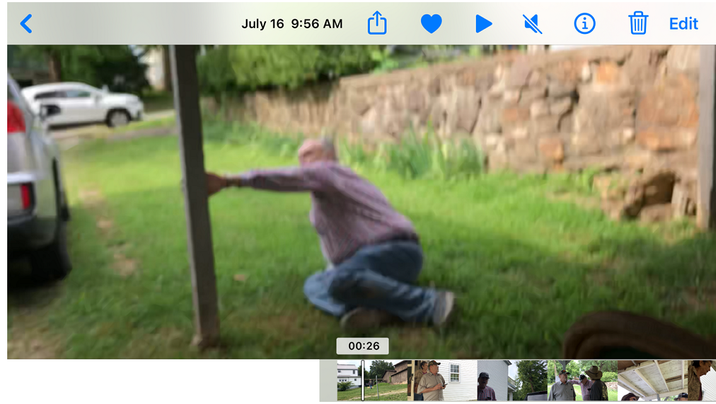
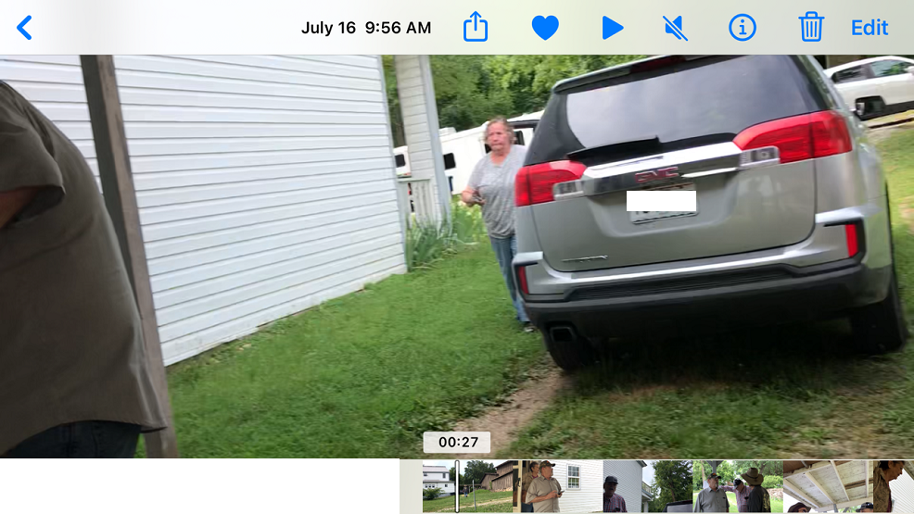
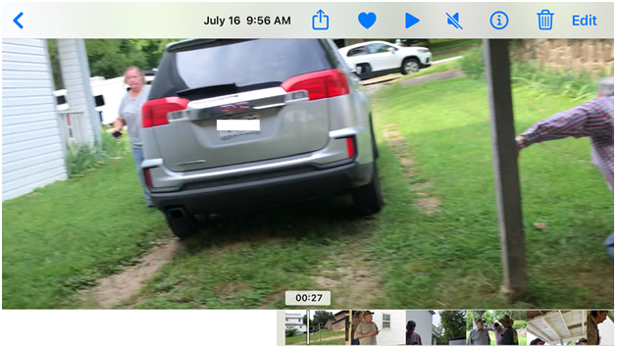
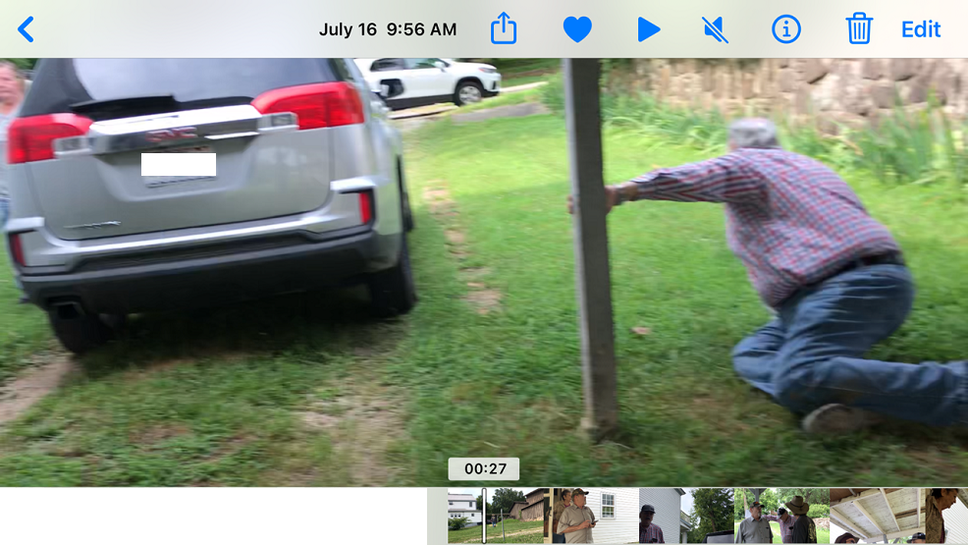
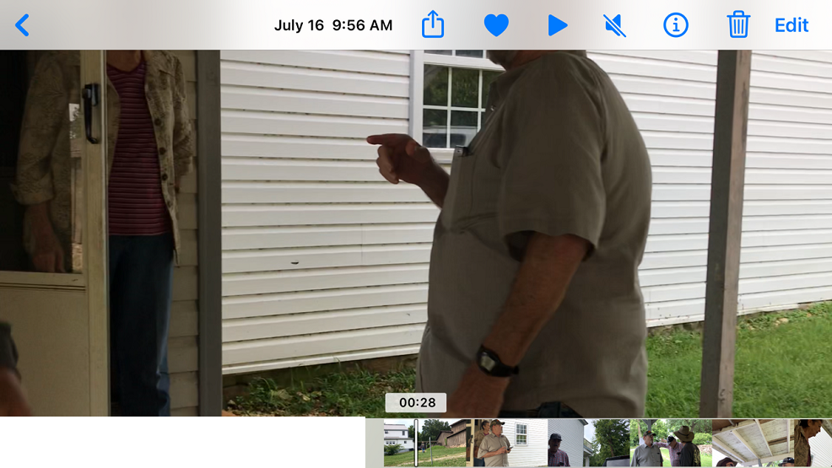
DAWN CAMPBELL: Hey, I’ve got it on camera. He hit first. (00:29)

DAWN CAMPBELL: Hey, I’ve got it on camera. He hit first. (00:29)
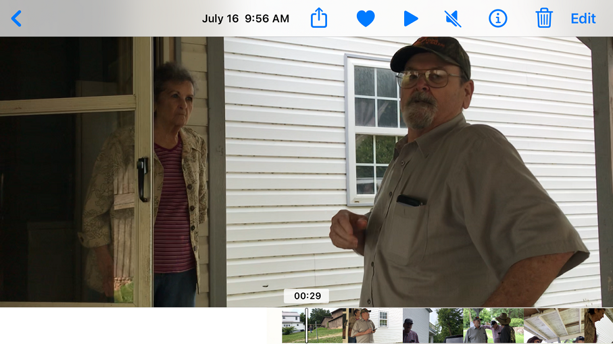
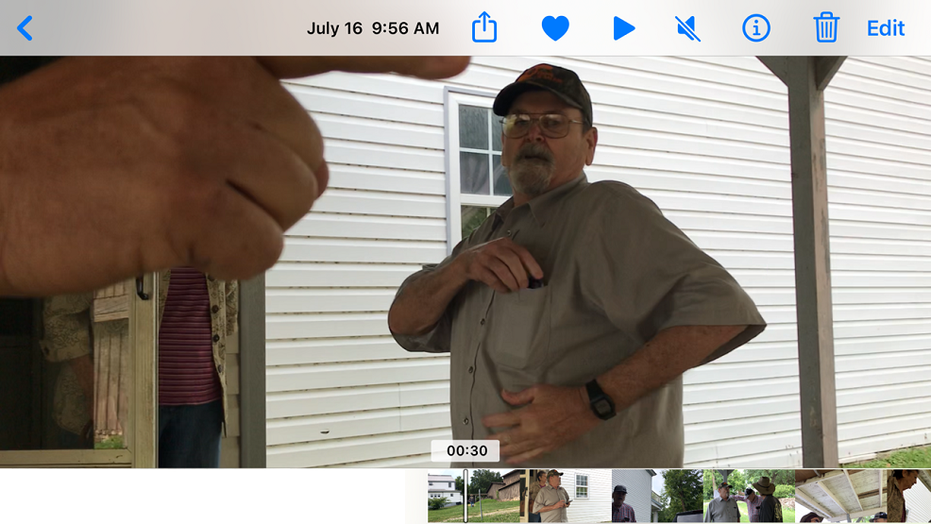
DAVE CAMPBELL: He touched me. (00:31)
RANDY DUNN: He did not. (00:31)
DAVE CAMPBELL: He kept pushing the sh*t out of me. Now, back off me. (00:31)
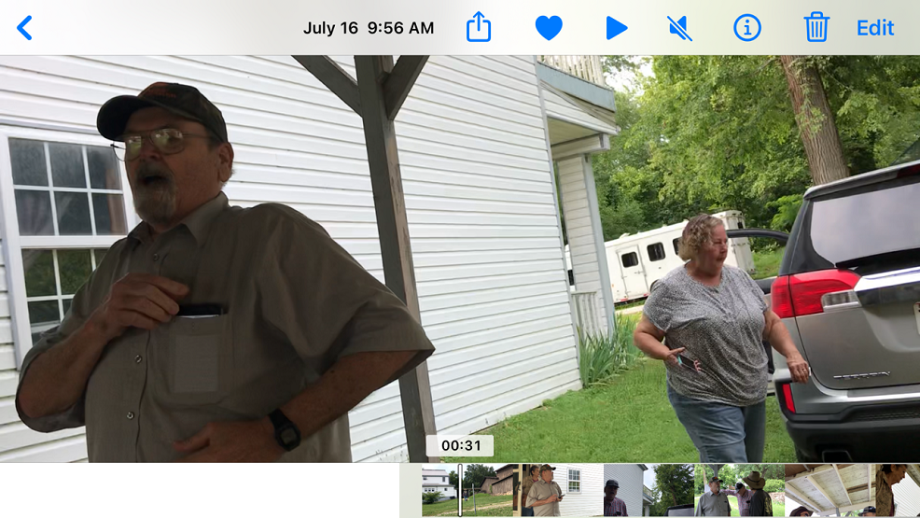
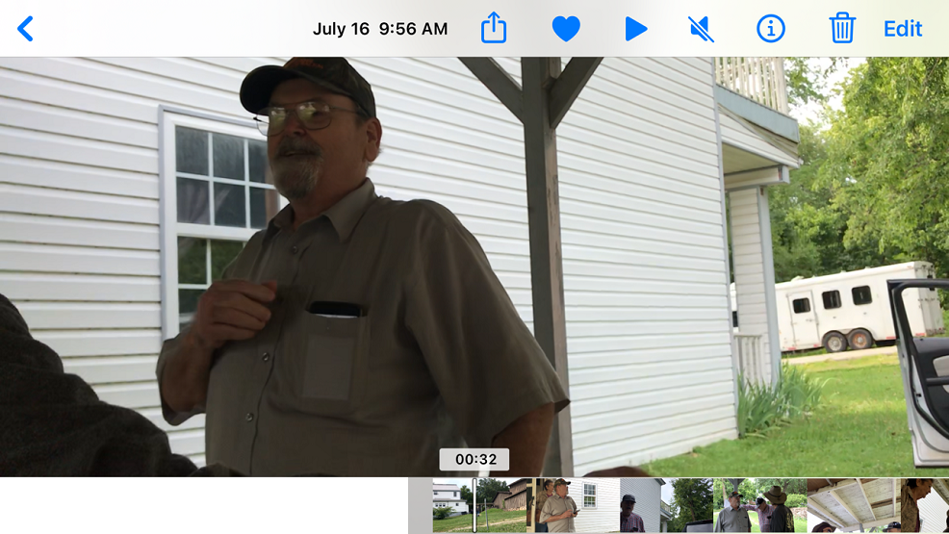
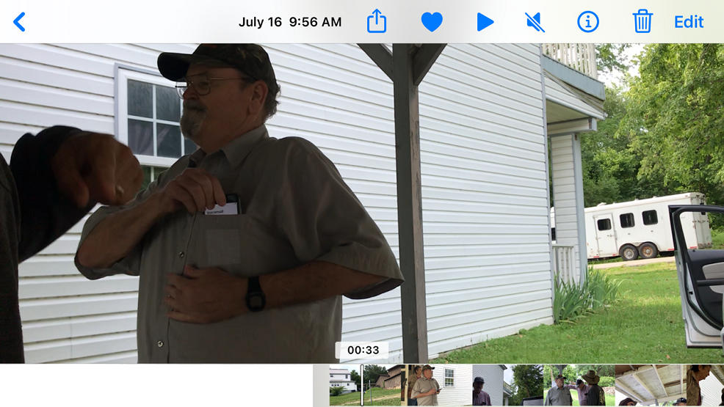
DAWN CAMPBELL: He sure did. (00:34)
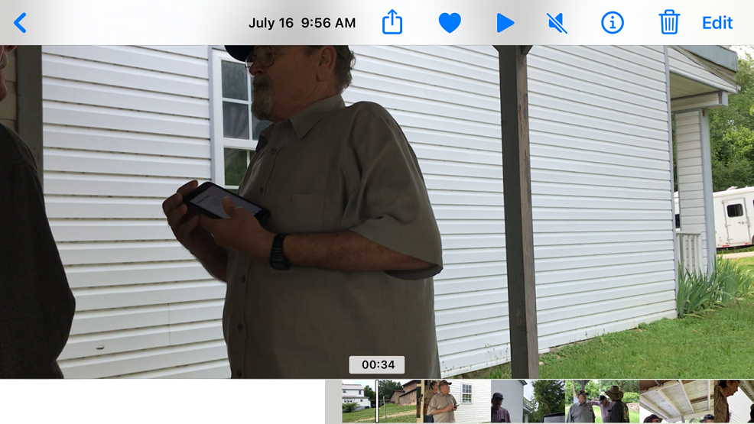
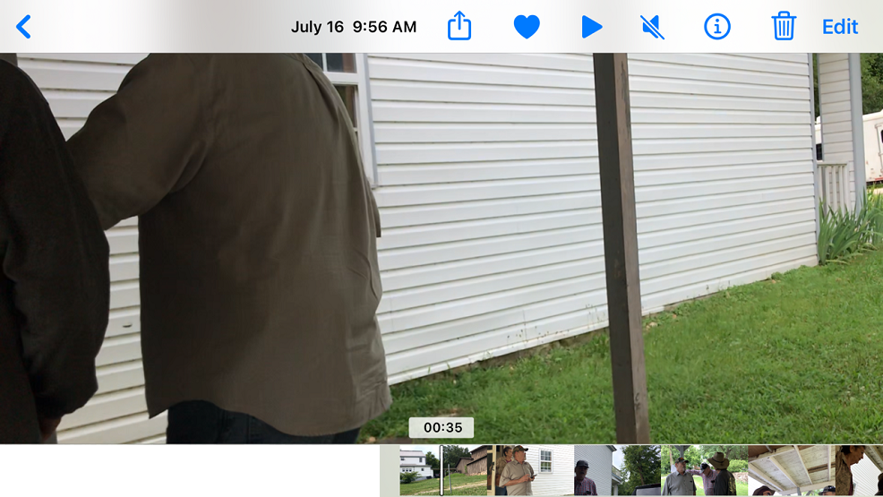
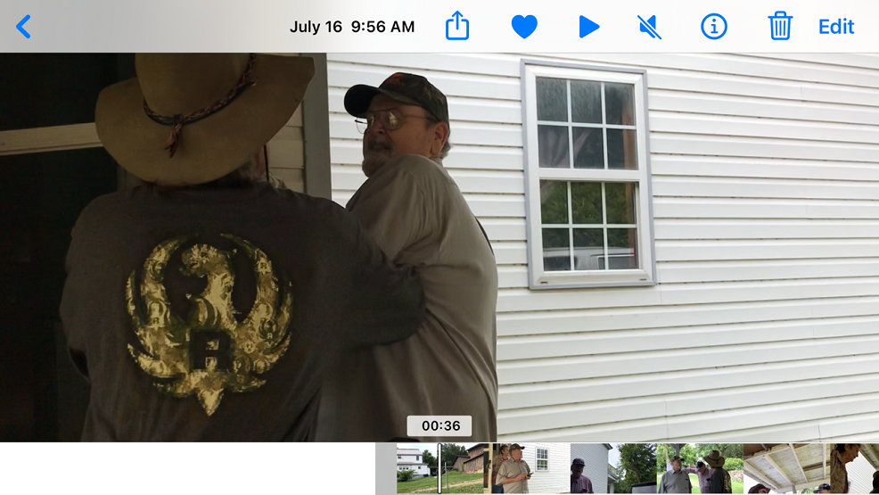
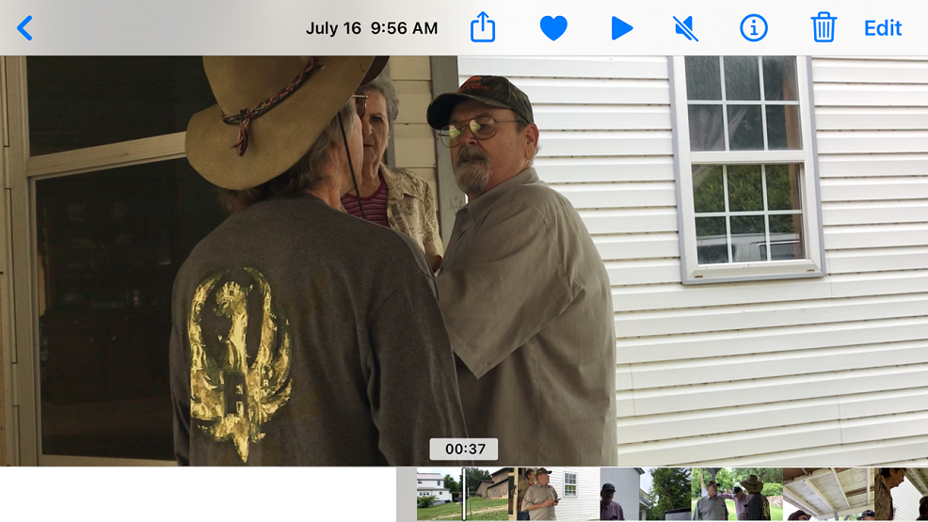
RANDY DUNN (to Dave Campbell): Don’t -- You can’t go in this house. It’s mine and Gary’s. (00:37)
DAWN CAMPBELL: Betty lives here. (00:38)
DAVE CAMPBELL: Oh, is it? (00:38)
RANDY DUNN : Yes. (00:38)
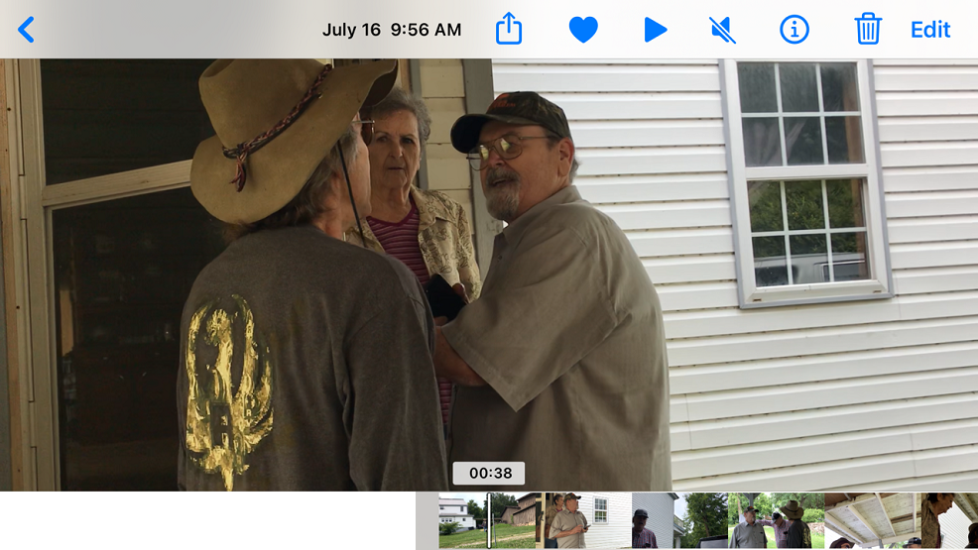
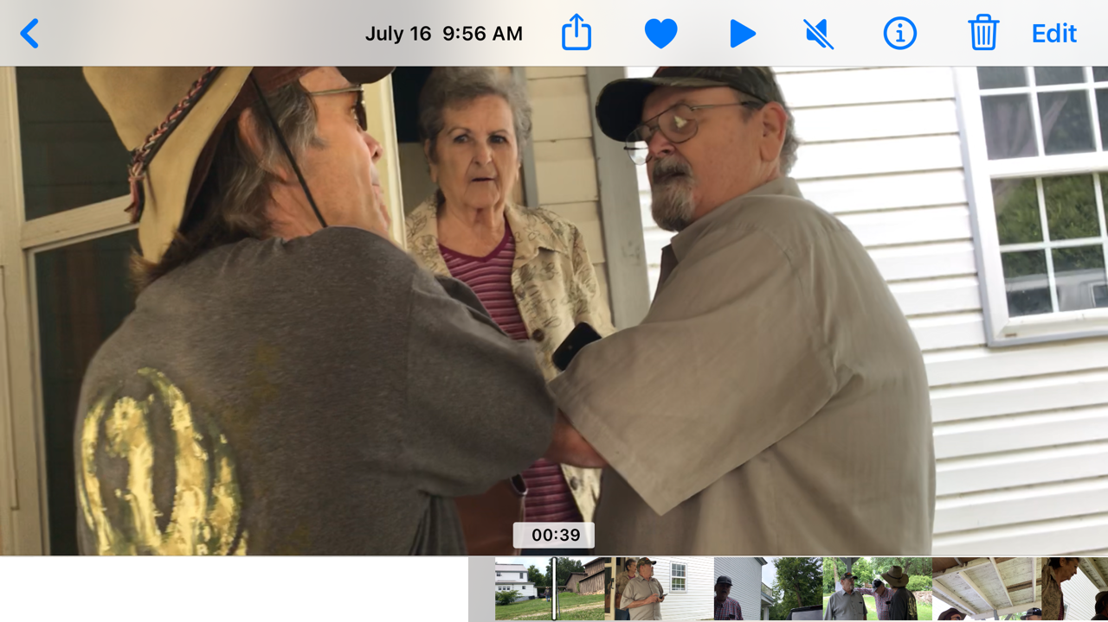
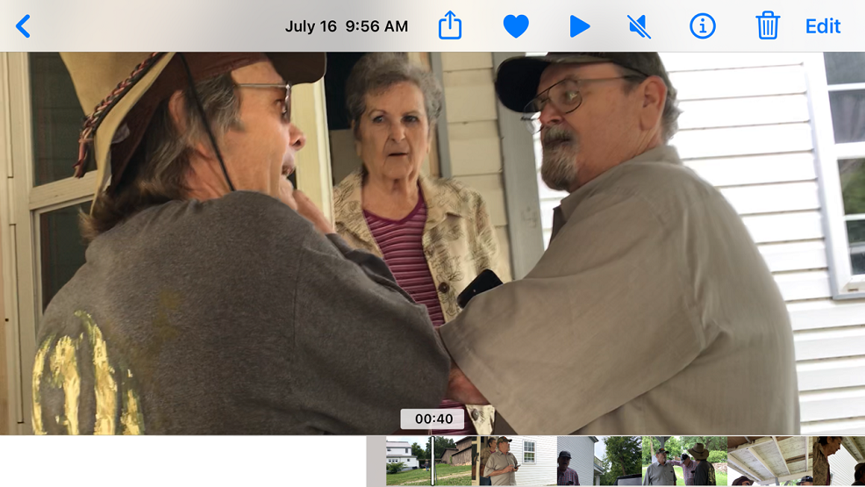
RANDY DUNN : Yes. (00:38)
DAVE CAMPBELL: Well, that’s funny, because they’ve got paperwork down there that says it’s not yours. (00:41)
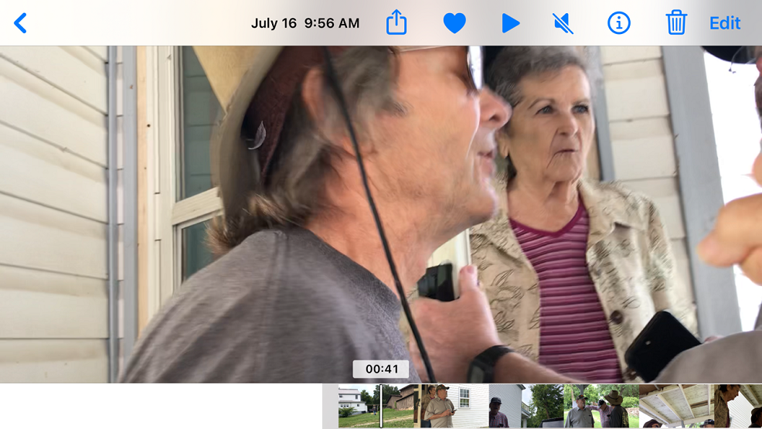
DAWN CAMPBELL: Okay. Let’s let Betty talk. (00:42)
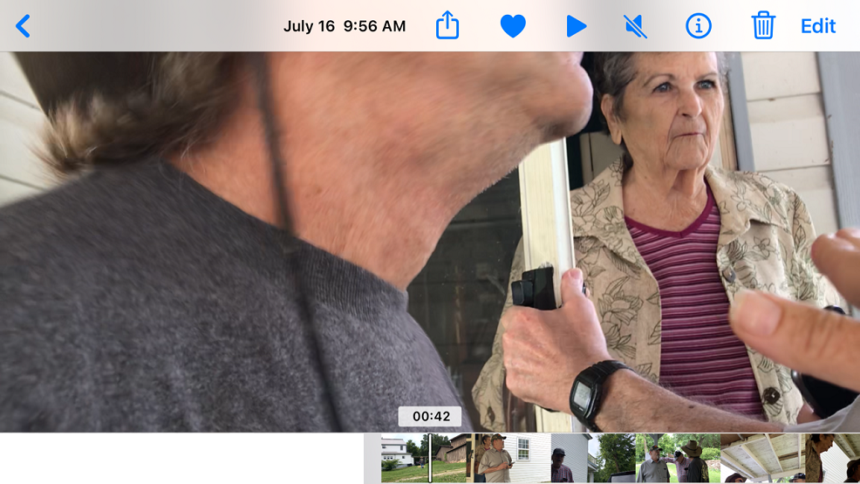
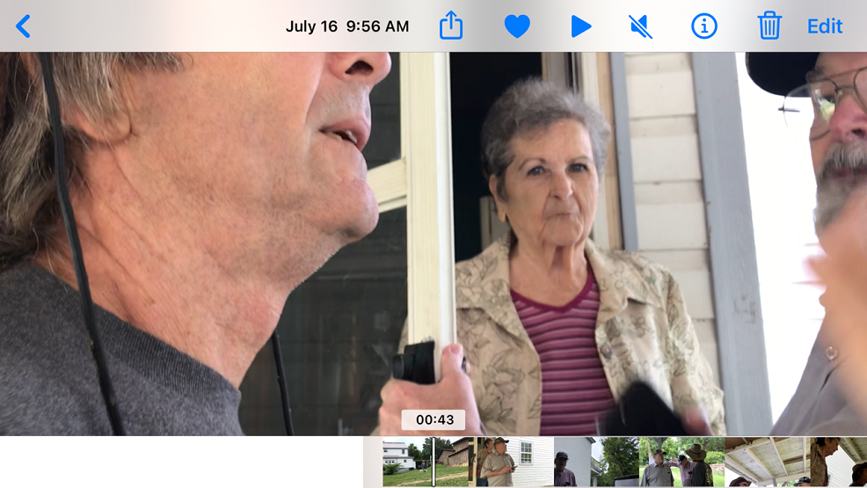
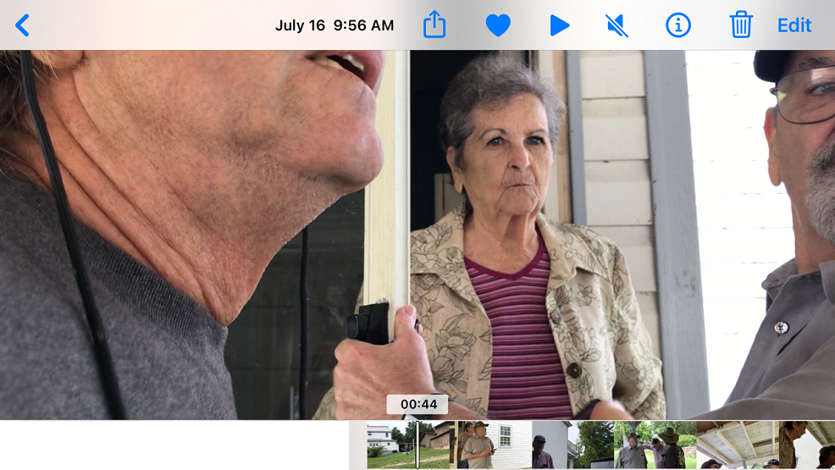
RANDY DUNN: All they’ve got now it says it is. (00:45)
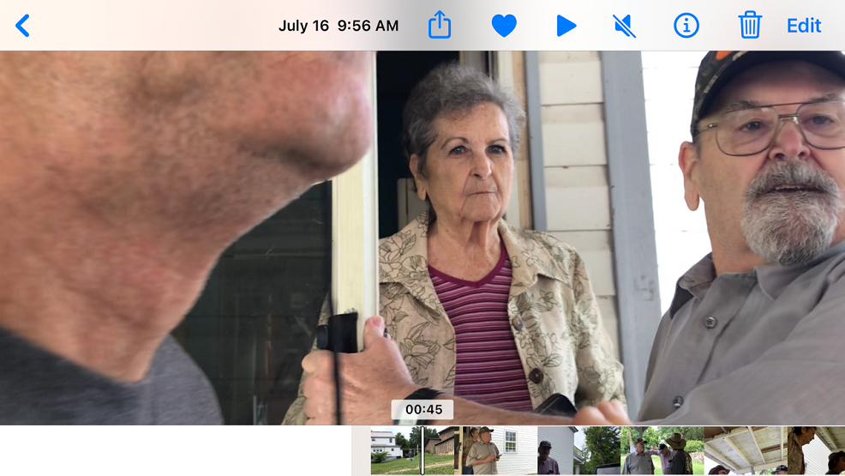
DAWN CAMPBELL: Let’s let Betty talk. Let’s let Betty talk. Okay? (00:45)
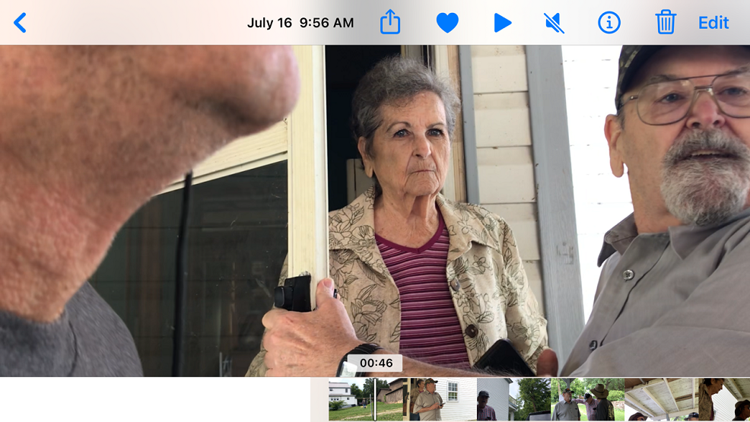
GARY DUNN: She needs an evaluation. (00:47)
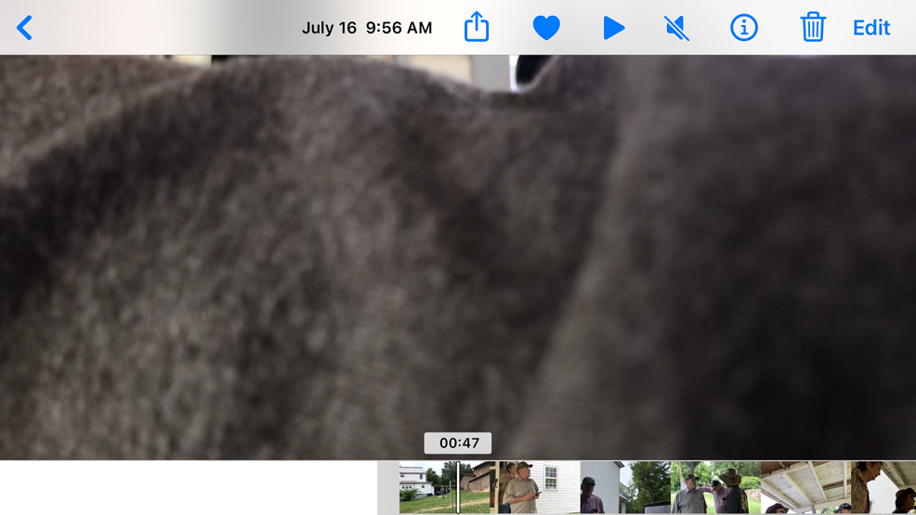
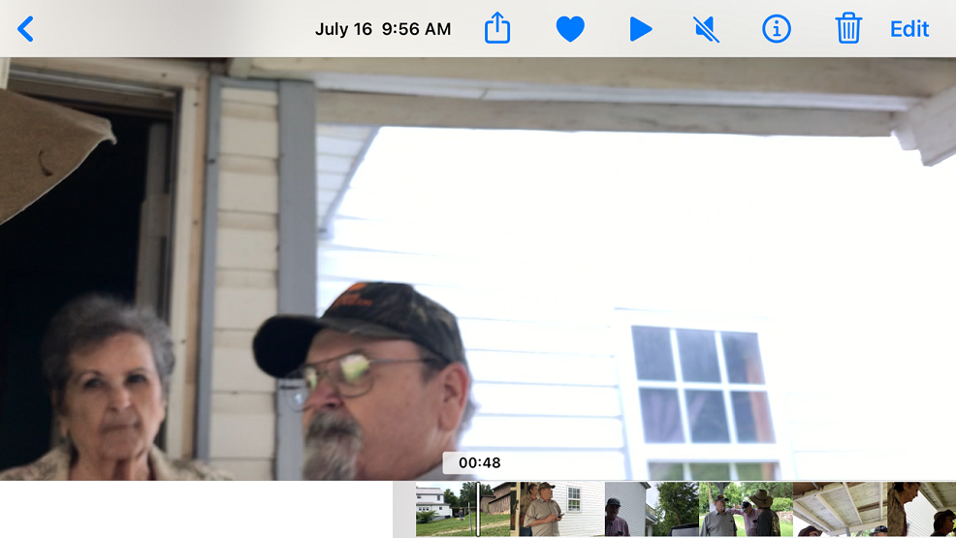
DAVE CAMPBELL: Is this Gary? Is this Gary? (00:49)
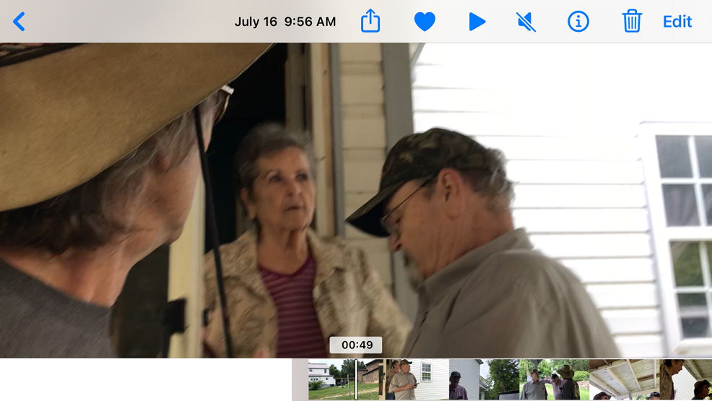
GARY DUNN: Yes. (00:50)
BETTY DUNN: That’s him. (00:50)
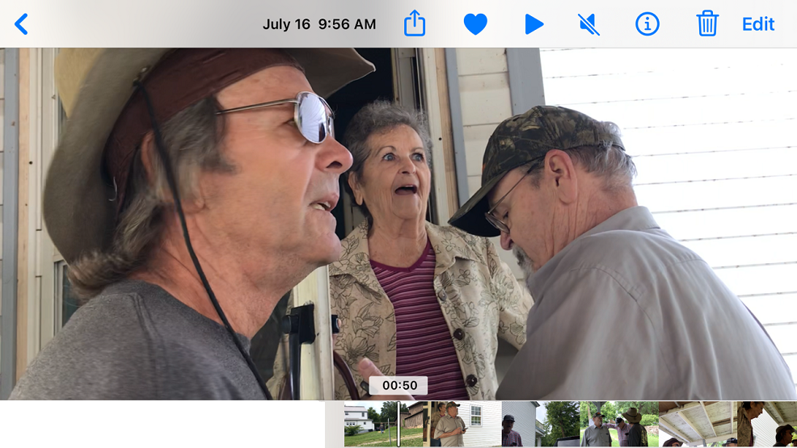
(Gary Dunn is back on his feet and standing near Dave and Dawn Campbell.) (00:51)
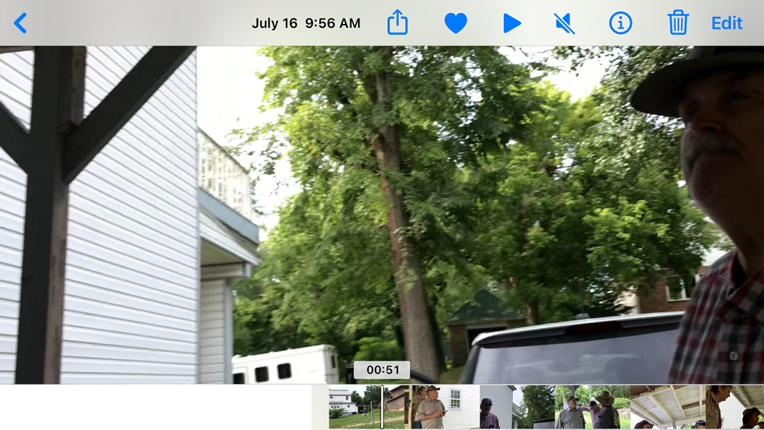
DAVE CAMPBELL: Sh*t. He’s just as bad as this guy. (00:52)
DAWN CAMPBELL: Do you want to go with him, Betty? Do you want to go with him? (00:54)
BETTY DUNN: No. (00:55)
RANDY DUNN: He ain’t taking her nowhere. (00:56)
DAWN CAMPBELL: (to Betty) Well, if you don’t want to go, you don’t have to go. (00:57)
GARY DUNN: It’s not even up to her. (00:59)
DAWN CAMPBELL: Yes, it is. (1:00)
GARY DUNN: This is the hospital. (1:01)
DAVE CAMPBELL: The hospital? (01:02)
BETTY DUNN: Oh, you’ll think hospital. This is my home. (1:03)
DAWN CAMPBELL: You don’t have to take her to the hospital. (01:04)
DAVE CAMPBELL: Let’s see it. Let’s see it, because you’re going to have to show the cops here in a second, because they’re on their way after I called, A**hole. (1:05)
BETTY DUNN: This is my home. (1:09)
GARY DUNN: Let’s see where you’ve got it that we own this. (1:10)
DAWN CAMPBELL: What? (1:12)
DAVE CAMPBELL: You own the house? You took her house away from your mother?
RANDY DUNN: No, we didn’t.
DAVE CAMPBELL: That’s fine and dan —(01:12)
RANDY DUNN: She give it to us.(1:14)
DAVE CAMPBELL: She give it to you? (01:16)
RANDY DUNN: Yes, back when she had some sense, before the Dementia kicked in so bad. (1:21)
DAVE CAMPBELL: Oh, that makes a lot of sense giving her house away of forty years. (01:23)
DAWN CAMPBELL: Okay. Okay. (00:24)
RANDY DUNN: Yeah. (01:25)
DAWN CAMPBELL: Dave, let’s just wait for the cops to get here. (01:26)
BRENDA DUNN: Yeah, you’ll think cops, Hun. (01:29)
DAWN CAMPBELL: Well, they’re on their way. (01:31)
BRENDA DUNN: Yeah. They need to be. (01:33)
DAWN CAMPBELL: Yeah, they do. (01:34)
BRENDA DUNN: There ain’t no sense in none of yuns doing this. (01:35)
DAWN CAMPBELL: Doing what? (01:35)
BRENDA DUNN: What you’re doing.(01:37)
CERTIFICATE OF TRANSCRIPTION
I, Catrenia Dawn Campbell, served as a Certified Shorthand Reporter for the State of Oklahoma. This transcript was created to the best of my ability and is taken from a video recording I made at 435 Bethel Avenue in Mammoth Spring, Arkansas on July 16, 2024. The numbers at the end of each statement are the approximate time of each statement’s ending. Many statements were stated at the same time. Some statements were indiscernible. To verify each statement, the video evidence is located at the following secure web link at You Tube:
https://youtu.be/iOXR0yjHgNM

Respectfully Submitted,

/s/ Catrenia Dawn Campbell
_________________________________
Catrenia Dawn Campbell 10/06/24

